2023 Gateball Captain’s Course

Presenter’s notes, including court-leader notes

Held 20-21 May 2023, at Eildon Croquet Club

Better Captains Making Better Teams

Topics covered:

Introduction

Training techniques

Self-reflection, Part 1

Back-to-basics

Probabilities and Success

Risk, Failure and Mitigation

Leadership of a team

Communication

Invading Another Team’s Space

Defending Numerically

Clusters

Defensive Gateball

Fighting your way back

Training, Motivation and skills

The first 10 minutes

The middle 10 minutes

The final 10 minutes

Self-reflection, Part 2

Blitzkrieg – and how to beat it

Conclusions

|  |  |
| --- | --- |
|  |  |

# Introduction [Philip]

Acknowledgement of Country

Welcome to the course!

Introduce the presenters.

* Philip Brown (GBHPM, Kew)
* Glen Whitehead (Canberra)
* John Park (former national Co-Ordinator, Hazelbrook)
* Geoff Crook (SA Co-ordinator, Hyde Park)
* Barbara Northcott (Former Qld Co-ordinator, Southport)

Why the course was created:

* ACA provided the funding for this course.
* Idea is to see Australian teams win more often in an international context.
  + At World and Asian Championships.
  + Against visiting international teams at the National Championships.
* First, we are trying to raise the standard of Gateball at all clubs.
  + Most clubs have strong skills (croquet influence).
  + Many clubs have weak strategic Gateball.
  + Move each club up one category.

What you should hope to get out of this weekend:

* Enjoyment – we’re all here to have fun and learn.
* A deeper understanding of the game of Gateball.
* Bringing concepts you intuitively understand to the surface and naming them.
  + Once you have names, you can see how the ideas interact.
  + You can communicate the ideas to your teammates more easily.
* Actual games – we will be playing games and doing drills as well.
* Advanced Gateball strategy and tactics – in particular, numerical play.
* Tools to better analyse a Gateball position.

How the course will work

* We’ll have group discussions here, then four courts with 6 people per court.
* We’ll randomly allocate you to a court now and again tomorrow morning – and the leaders will move between courts so you have different leaders for each session.

# Training Techniques [John]

**Train Ugly? Training Techniques to Promote Success for Your team**

**Practice**

Block: same action again and again...vs...Random: building in some variety

Random Practise makes you read, plan, do. Practising Skill Sequences is the ideal way to go for GB

**Reviewing some past practice**

|  |  |  |  |  |  |
| --- | --- | --- | --- | --- | --- |
| **Dates** | **Programs** | **Block** | **Random** | **Tallied?** | **Motivates?** |
| 2006 | Keith McLeod. 100 balls through G1 every day!  Gateball Information Pamphlet No 6 (gateball.com.au/Coaches Corner/ Gateball Information Pamphlet 005 Practice Routines |  |  |  |  |
| 2009 | Qld State Team practises, trains and competes at the 2009 AGC |  |  |  |  |
| 2010 | Gateball Skills Carnival -(gateball.com.au/Coaches Corner/Basic Drills/Skill Cards and Programs to use) |  |  |  |  |
| 2011 | Wagga Wagga's TRAC School team learn, train and compete in the 2017 AGC. (gateball.com.au/Coaches Corner/Basic Drills/Introducing Gateball to Groups...) |  |  |  |  |
| 2015 | ACA Coaching Program for the Foundation level: GB Basic Skills Card (gateball.com.au/Coaches Corner/Basic Drills/Skill Cards and Programs to use)  Gateball for Beginners Skills Cards (gateball.com.au/Coaches Corner/ Gateball Information Pamphlet 016/p12 |  |  |  |  |
| 2019 | CNSW PPEP Program based on AIS FTEM framework  Gateball for Competition Players (gateball.com.au/Coaches Corner/ Gateball Information Pamphlet 017/ Gateball for Competition Players) |  |  |  |  |

NB All but the 2009 item referred to above are available on [www.gateball.com.au](http://www.gateball.com.au/). As the site undergoes some changes you may have to search in “Coaches Corner”

**Activities.** With your session leader:

Use some of the activities in “Gateball for Competition Players” and consider their potential to enhance players' ability to play “Skill Sequences.”

Map where your “ usual team” is placed on the FTEM framework. Write initials in the table. Discuss how you can “train” your players given that they are at different places on the FTEM framework.

**FTEM MODEL & GATEBALL**

|  |  |  |  |
| --- | --- | --- | --- |
| **FTEM LEVEL** | **CRITERIA** | **GATEBALL SKILLS** | **SUPPORT** |
| **MASTERY**  **Sustained Success** | • Repeated international podium success over multiple years | Oustanding individual, team and thinking skills | High Performance Manager |
| **ELITE 2**  **Success** | • Podium success at a major international event  • Demonstrated team leadership and personal excellence | Oustanding individual, team and thinking skills | High Performance Manager |
| **ELITE 1**  **Representation** | • Selection to national teams  • Progression towards World Class performance standards | Individual, team and thinking skills of a high standard | High Performance Manager |
| **TALENT 4**  **Breakthrough & Reward** | • Achievement of a breakthrough performance and/or reward | Undertakes skill sequences with frequent outstanding plays  Important part of team leadership structure/Captains  Referees | Level 2 & 3 Coaches,Captain's Courses, Gateball for Competition Players, High Performance Manager, Resources on GA website |
| **TALENT 3**  **Practising and Achieving** | • Increased investment in practice and competition.  Attends State & Australian Championships and participates in triples and doubles | Undertakes skill sequences with occasional outstanding plays  Part team leadership structure/captains  Referees | Level 2 & 3 Coaches, Gateball for Competition Players, Captain's Courses, High Performance Manager  Resources on GA website |
| **TALENT 2**  **Verification** | • Verification of talent & potential during training and interclub and more challenging competition  • Initial exposure to high performance training | Competently undertakes skill sequences  Develops good team and thinking skills  Captains, at least in social games  At least a Referee in Training | Level 2 & 3 Coaches, Gateball for Competition Players, “Think Like A Captain Course,” Resources on GA website, Beginner Captain Courses, High Performance Manager |
| **TALENT 1**  **Demonstration of Potential** | • Initial demonstration of talent in competition & potential for development  • Expression of interest to expand ones knowledge and skills | Reliable basic individual skills & team skills  Refereeing team roles  Further develops thinking skills – can see options. May captain socially. | Level 2 Coaches, Gateball for Competition Players, “Think Like A Captain Course,” Resources on GA website, Beginner Captain Courses |
| **FOUNDATION 3**  **Committment/ Competition** | • Training & skill development  • begins involvement in competition | Competent with basic individual skills & team skills. Self corrects routines.  Develops thinking skills | Level 1 Coaches, GB for Beginners  “Think Like A Captain Course”  Basic Skills Cards |
| **FOUNDATION 2**  **Extend & Refine Movement** | • Initial introduction continues  • Recreational involvement in club games | Applies routines to basic individual skills  Develops team skills | Level 1 Coaches, GB for Beginners  Basic Skills Cards, Satoshi's Videos |
| **FOUNDATION 1**  **Learning and of Basic Movement** | • Acquisition of fundamental movement skills (Routines)  • having fun | Introduction to GB  Develops routines for stroking, sparking and sliding | Level 1 Coaches, GB for Beginner |

Draft May 2023

**Notes for presenters.**

You have two parts of the activity here. No need to rush through both if time is pressing but do have a discussion at the end rather than leave it all hanging in the air!

**1. Use some of the activities in “Gateball for Competition Players” and consider their potential to enhance players' ability to play “Skill Sequences.”**

Choose a some of these and play them with your group. You need to be familiar with the document which you can find at <https://gateball.com.au/wp-content/uploads/2023/02/Gateball-Information-Pamphlet-No.-17-Gateball-for-competition-players-4-FINAL.pdf> . A hard copy of the booklet will be available for participants at the event

The intention of this activity is to demonstrate exactly what we mean by random practice skill sequences and how we can use these to improve individual skills and maybe some thinking skills too. It would be great if we could encourage captain/trainers to developed their own skill sequences that were relevant to the needs of their team. You will note that there is a blank proforma in the booklet so please encourage participants to develop some which they can email to [info@gateball.com.au](mailto:info@gateball.com.au) and then shared more widely.

All the activities have a *Change it* and *Make it a game* prompt. The second is an attempt to build in a fun/competitive element while the first prompt encourages players to make changes to suit their own circumstances The worst thing that can happen is that templates for activities become fossilised and don't get adapted. Where you feel the instructions need amending for your session – just do it!

Some notes about the best ones to play:

-Some of the early “set up” examples *(1 to 4, pages 3-6 )* should probably be avoided. Not only are they a bit blocky but will be dealt with in a later session on openings. *14, Gate 1 Shootout* does not trespass on future sessions and you may wish to use it. I should also clarify that each ball entering the court can only remove 1 opposition ball. If you notice any other activities that trespass on later session please avoid them too.

-Gate Pass and Spark Back (Again and Again and Again on page 8) is a good activity to play as a game. One person plays keeps playing until they fail and then the other person tries to beat that number of gate passes. Please remember that when giving the instructions, the reception ball should be placed within a metre of Line 3. No sneaking up behind the gate! But, after playing once, by all means *Change it*

-13 Ladders and Chains is quite popular and people report that it is a challenge. It can be played out by one player or people can be assigned diferent balls. To engage more participants you can set up one colour heading for G3 while the other plays towards 2 ( just ignore the slight logical problem)

-16 Hunting Mk 2 acknowledges its origin. How many times have you been playing in a team, completed a G&T only for the opportunity to be squandered?

-8. Mini Endgame Slide Fest is a small scale activity. You could set it up behind G1,2 or 3 to keep everyone busy if you wish. This sort of situation is interesting because it is a challenge for a captain to be able to give instructions for each stroke or spark quickly enough. It's an example of where a player needs to “Think Like a Captain”

Once you have completed some activities, please have a short discussion with your group

* Are they clear about the difference between block and random practice
* What are the differences and similarities between random practice and skills sequences? (Example for your information: Just stroking lots of balls through Gate 1 from different points across the whole start area is random. It becomes a skill sequence, but still random, when you play the continuation stroke to an agreed destination
* Can they think of other random practice activities? If so, please share!
* What makes a good random practice drill but others less successful
* Are participants able to get their teams to practice? What are the issues? What do they do?
* Can they think of any situations where block practice may be useful ( Examples for your information: 1. where play in a comp has revealed a very specific issue like tapping on. 2. Where a player could be thinking out how to spark when the gate appears to impede a preferred sparking direction 3. If you believe your players should be taught rare plays like jump strokes, jump slide touches or jump sparks 4.Fairly inexperienced players)

**Map where your “ usual team” is placed on the FTEM framework. Write initials in the table.**

# Self-Reflection, part 1 [Court Leaders]

Play a game, 3v3 on each court.

Once you’ve finished, stop and ask yourselves these questions:

Did the team that was better at hitting the ball win?

Why did the team that won, win?

Accuracy?

Strategy?

Luck?

What were the key moments of the game?

What captaincy techniques were used?

What would you do differently if you had your time over?

Did you identify any weaknesses in the other team that you could use later on?

# Back-to-Basics [Philip]

Most of the course will not be these small tactics – but we need to start with a couple of simple ideas. Importantly, we need to give these ideas names, too.

**Zones of control**

The area that the ball could easily touch another ball - if one was placed there. Think about the size of the zones… what affects them?

*Consider the court diagram below. First, assume ball 1 is next to play, what is ball 1’s zone of control? Next, instead of ball 1, assume ball 2 was next to play with all balls in the same positions. What is ball 2’s zone of control? Then ball 3, etc. Which balls have large zones, which small? Which is largest? Which smallest?*

**Each Gateball shot is made up of a direction and a strength.**

What line did you want to hit the ball along. How hard do you want to hit it?

When there’s a chance you might miss, how hard you hit the ball is a key consideration – where do you want to “accidentally” end up?

**The ice-cream cone of opportunity.**

Most players find it easier to hit the ball straight, than to hit the ball the exact desired weight. As such, when you ask a player to aim at a particular spot, they are more likely to land short or long and less likely to be left or right. This ice-cream cone shape is very important when analysing a shot. If every part of the ice-cream cone is a good outcome, that’s a good shot.

**The Three Ball Gate-Setup**

While a gate-touch strictly speaking requires only two balls, it’s much easier with three. The best position is to have three balls almost in a line.

The ball to play first should be furthest from the gate, with another ball just in front to allow it change angles. Finally, you need a ball behind. Very important that the GT be attempted to be set so that the second ball could hit the third.

This approach has two main benefits – it makes the gate-touch more likely. It also means the opposition must assume a gate-touch is possible and take defensive actions, even if it doesn’t actually come to pass.

Court Exercises:

Play around with the structure of the three balls for a three-ball gate-setup. Figure out what works reliably for YOU. Different players will have different preferences.

*DRILL: Play balls 1 and 3 onto the court. The aim is to set these two balls such that a gate-touch is achieved by ball 5. There are many different approaches – find the one that works most reliably for you. Note you can also sometimes set a touch-gate with a ball just in front of the gate. Use Gates 2 and 3 simultaneously. If the players get good at this, try ball 3 in other positions.*

# Probabilistic Gateball – Part 1 [Glen]

**Aim**: As a captain you consider the likelihood of your teammates and opponents making certain shots.

This exercise will quantify the success rate of certain shots.

In a match we get feedback from the success of a shot with a small sample size, often a certain shot will only occur once in a match. Collecting a larger sample will give a more accurate indication of the chance of success (for our group of participants, on a given court, on a given day).

In this exercise we will record our predictions, discuss the rationale for these predictions, refine our prediction and compare with others and the actual results.

Certain captains may have optimistic or pessimistic predictions which could be considered when improving your captaining.

|  |  |  |  |  |  |
| --- | --- | --- | --- | --- | --- |
| Shot | Predicted Chance of Success (%) | Average prediction  (%) | Predicted chance of success after discussion (%) | Average prediction  (%) | Actual (%) |
| 2m ball touch |  |  |  |  |  |
| 4m ball touch |  |  |  |  |  |
| 6m ball touch |  |  |  |  |  |
| 11m touch from behind gate 2 to a ball in front of gate 3 (single ball) |  |  |  |  |  |
| 11m touch from behind gate 2 to two balls in front of gate 3 (balls are one ball width apart) |  |  |  |  |  |
| Gate 1 and then gate 2 |  |  |  |  |  |
| Angled gate from border on 45° (2.8m shot) |  |  |  |  |  |

# Risk, Failure and Mitigation [Geoff]

**The Devil and the Deep Blue Sea**

*Objectives:*

1. To demonstrate the role of risk assessment and player ability in choosing strategic options.

*Introduction:*

Often in a game, a captain will be faced with a difficult choice. In the example below, all balls are for Gate 2 except Balls 7& 8, which are for Gate 3. Ball 6 is an Out Ball, and Ball 3 is to play. Ball 3 is closer to Ball 10 than Ball 5. 15 minutes remain. Ball 8 has a gate touch on Ball 10.

What should Ball 3 do?

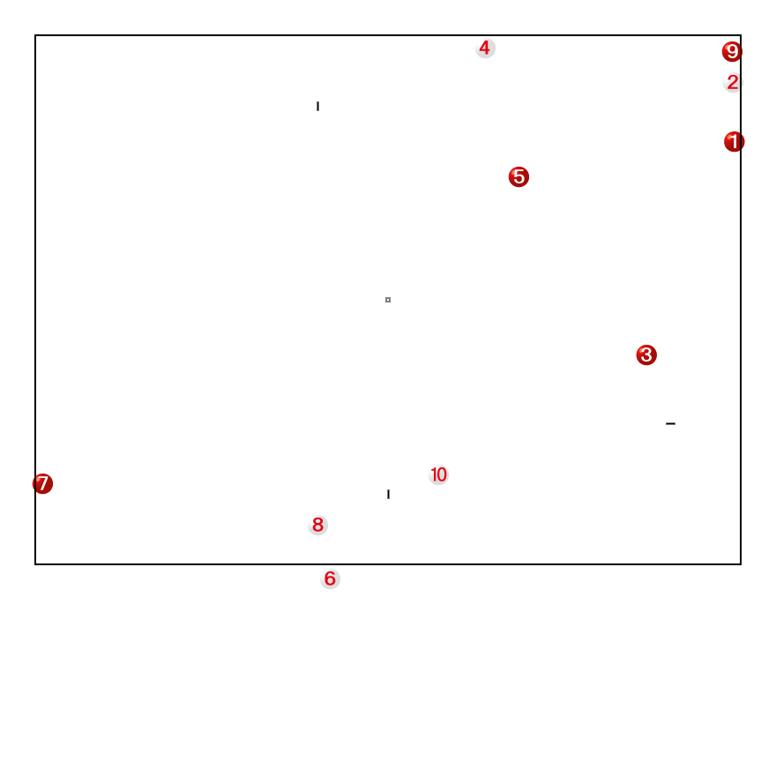

1. **Leaders Notes:**

* Identify strategic problems for red:
  + Ball 4 touch on Ball 5 and possible bombard
  + Ball 8 has a gate touch
* Discuss options for Ball 3 to neutralise Ball 4 threat
  + Touch Ball 5, and then touch/knock out Ball 4 [optional slide off Ball 5 to Ball 4]
    - Straw poll - who thinks they would make both shots? [Yes on left, No on right]
    - Get a couple of Yes to demonstrate, and a couple of No [point is to see what happens if ball 3 misses – opportunities for Ball 4! – Discuss potential for Ball 4 to set slide off Ball 5 after touching Ball 3]
  + Don’t worry about it!
  + Any others? [may get something out there like make gate 2] – ask for a demonstration!
* Discuss options for Ball 3 to neutralise Ball 8 threat
  + Touch Ball 5, and spark to Ball 8 [maybe use Ball 10 as gate touch for Ball 7. Bridge using Balls 3 and 5.
  + Touch Ball 5, and spark to Ball 7– better option as Ball 7 can then use Ball 10 for gate touch once Ball 5 sparks Ball 7 to Ball 8 - only if Ball 6 out or unlikely to interfere. Danger Ball 4 may pass Gate 2 and have a go at Ball 5 though.
  + Touch Ball 10 and then Ball 8 [then bridge for Ball 7] – safest, but maybe least favourite option as Ball 10 no longer available for Ball 7 to get gate touch -depends on team skills.
  + Bridge for Ball 7 [also use Ball 5 whether put out by Ball 4 or not]
  + Any others? [may get something out there like touch Ball 7!] – ask for a demonstration!

For each option:

* Straw poll - who thinks they would make the shots? [Yes on left, No on right]
* Tally results announce which option most feasible
* Play each scenario up to Ball 7 a couple of times – first with players that think they can make the shots and then with players that don’t think they can make the shots.

**Discussion points**

* Would your answer change if Ball 4 was in NW corner [corner 3]
  + I would probably build bridge and take chance Ball 4 won’t hit Ball 3 or Ball 7, although the shot at Ball 5 becomes less risky.
  + How do you mitigate the risk of the shot at Ball 5? How hard do you hit the ball?

**Key Learnings**

* Strategy needs to be matched to the team’s skills.
* Best way to improve results is to encourage team to improve skills. Improved skills opens up many more viable strategies.
* Each shot has a risk/reward attached, based on each player’s ability. Assessing these is key to success.

**Scenario: How do you shoot the Devil in the back?**

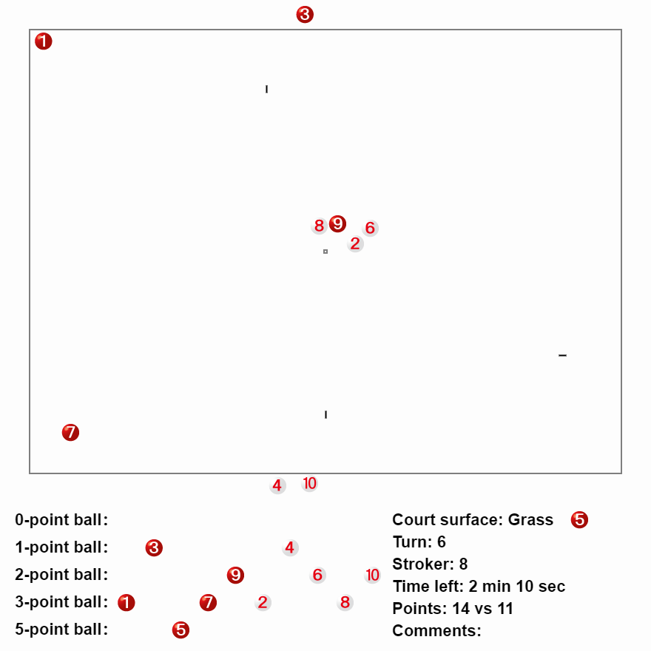

The game is nearly over. Ball to 8 to play. The white team is behind by 3 points.

**Scenario: How do you shoot the Devil in the Back? (intermediate)**

Guidance:

Ball 8 should clearly touch the balls in the centre of the field.

The question is what should be done with them. There are a number of questions here.

While bombarding ball 1 with ball 9 may seem appropriate. If you miss, then 9 comes on as a rush ball and invites ball 1 to the goal pole.

Ball 9 should be sent near the start area. Ball 2 should probably be put on the pole.

With very little of the game left, it is quite unlikely that ball 6 will get to play. So while sending 6 to 7 is not a bad idea, perhaps trying to bombard ball 1 with ball 6 is good too.

# Leadership: The importance of humility [Barbara]

This session is focused on the qualities that are desirable for a Captain to possess in order to be successful both on and off the field.

For this small, introductory segment you have a piece of paper called “Leadership in Gateball” on which there are three columns. One is listed as Always, one is listed as Sometimes and one is listed as Never. You will work in pairs. Please be prepared to debate your answers with a person in the group who is not well known to you thereby debating with someone who may have differing ideas. Then, Place a **Tick** in the column that represents your own opinion.

#1. A Captain is a person who can analyse the tactics of teams.

#2. A Captain is the best player in the team.

#3. A Captain has the loudest voice in the team.

#4. A Captain is a qualified Coach.

#5. A Captain makes the final decision for the team.

#6. A Captain is a qualified Referee.

#7. A Captain listens to the what a team member says during a game.

#8. A Captain buys drinks for the team after the game.

#9. A Captain knows the strengths and weaknesses of the team members.

#10. A Captain has an outgoing personality.

Now it is time to reassess your responses to see if you are aware of what are the ideal qualities in order to be a very successful Captain. The best responses are

#1 Always

#2 Sometimes

#3 Sometimes

#4 Always

#5 Always

#6 Sometimes - best to be Always

#7 Always

#8 Never

#9 Always

#10 Sometimes

People are different as we all would agree. But the important

**Behavioural Characteristics** of effective Captains are as follows.

For Gateball Captains it is essential for the Captain to be

* Dedicated to the role
* Hard working at own skills
* Focused on all the members in the team
* Unselfish and humble
* Strong in self- esteem and confidence in his/ her knowledge of the game and their own ability
* Respectful at all times of the opposition players, referees, officials of the Gateball Community and those officials at State and National level.
* Are very good role models.
* Accept personal responsibility for own actions.

I am going to share with you an item in the Business Section of “ The Australian” newspaper. It is writing about business leaders but is just as relevant to sports leaders and Gateball Captains as well.

**News item from the Business Pages of “The Australian” Newspaper ,   
May 6-7, 2023**

“Humility goes to the heart of great leadership, according to the head of global executive think tank, ‘The Leadership Circle’, Mark Burrell, who says these kinds of leaders are consistently rated as decisive, visionary and purposeful, with a ‘connection to something bigger than the personality of the leader.’

‘Leaders lacking humility are often invested in their own sense of rightness, although this can be hard for them to acknowledge’, says Burrell. ‘This kind of leadership has pay-offs to be sure, but the downside is the inability to take in discomforting information and the tendency to create a culture of certainty and arrogance.”

(The item referred to a woman who was announced as being the new Chief Executive of Qantas.)

**DISCUSS**

In addition to the behaviour characteristics of a good leader or Captain in the Gateball environment that I have been outlining, there are **skills** that will ensure the effectiveness of a Captain.

Below are **Leadership Skills** that are crucial to the success of the team.

1. Interpersonal Skills are critical. A Captain of a team builds relationships within the team members, understands how to develop the players to their maximum of abilities, and creates a unity of purpose.

2. Communication skills are another of the essentials that a good Captain requires. It is having the understanding of and the ability to adapt the message to the situation for the individual team member.

3. Knowledge of the game is a skill that has evolved and developed over time. An effective Captain has ‘studied’ all aspects of the game; the various strategies that are most suitable for the team as well as for the individual team member; and continues to study the game and it’s intricacies.

4. Decision making is another critical aspect of being a successful Gateball Captain. Being cool under pressure is an absolute ‘game changer’ for an effective Captain. This skill will be developed over time but it is also an inherent quality of the person who aspires to be an excellent Captain. Whether a person is an extrovert or an introvert, the credibility of a Captain requires calmness in a stressful situation.

5. Mentoring and support of all team members will be a necessity in the creation of a successful team so these coaching skills are another critical asset for a Captain. Analysing and identifying the perceived problem areas of a team member’s skill set will ensure a better performance by that player.

6. Inspirational skills are highly valued in a Captain’s repertoire if he/ she is to be able to enthuse the team and foster the highest standard of behaviour of the team members. Establishing a very good sporting culture within the team is the hallmark of a top quality Captain.

7. Self Awareness will ensure effective leadership. The Captain’s self-awareness of his/ her personality style and leadership style encompasses the myriad of decisions that are required. A great Captain understands their own strengths and limitations as well as their own motivations.

**Leadership in Gateball**

|  |  |  |  |
| --- | --- | --- | --- |
| Statement | **Always** | **Sometimes** | **Never** |
| #1 |  |  |  |
| #2 |  |  |  |
| #3 |  |  |  |
| #4 |  |  |  |
| #5 |  |  |  |
| #6 |  |  |  |
| #7 |  |  |  |
| #8 |  |  |  |
| #9 |  |  |  |
| #10 |  |  |  |

# Communication: Giving and Receiving Information [Philip]

**Giving information clearly. You only have 10 seconds!**

While you can give information only in terms of what the shot should be, if a player understands why the shot is being made, they will often understand better – and faster. For example.

“Hit the ball about 75cm in front of gate, at a 45 degree angle back towards the line.”

Or

“Gate 2 straightener for Ball 3”

This requires all players on the team to have a common Gateball language. This will include names for both physical places on the court and for game concepts.

This needs to be practiced inside clubs before competitions. However, it would be better for Australian Gateball if the various teams had as much cross-over as possible. This will make combined teams more cohesive. Are there any other places your team gives a name to?

“Japanese” position has fall out of use now. “Reception deep behind Gate 2” is probably better.

Notice that behind gate 2 and gate 3 are straight behind. Behind gate 1 assumes the normal gate 1 angle. I

“**In the jaws**” – which means just behind the dead centre of the gate. Essentially makes any gate a gate-touch.

Names for common Gateball concepts:

1. **Gate-touch** – passing the gate then touching another ball.
2. **Touch**-**gate** – touching another ball and then passing the gate. Called an “In-off” in Golf Croquet.
3. **Slide / rush** – a ball to allow another ball to deliberately nick off the side and change position.
4. **Straightener** – a ball deliberately placed in front of a gate to allow another ball to improve their angle on the gate.
5. **Guard** - deliberately placing a ball on a 45 degree line to the gate near the sideline.
6. **Cluster** -a group of balls. Normally at least 3.
7. **Ladder/bridge/chain** – a line of balls allowing one ball to cross considerable distance in multiple short moves.
8. **Bombard** – deliberately using a spark to force another ball out of bounds.
9. **Push Out** – deliberately touching a ball and knocking it out of play, even if both balls become out balls.
10. **Wired** – When two balls which are relatively close can’t score a touch against each other because there’s something in the way (normally a gate – also the goal pole).
11. **Tight to the line** – leaving a very ball very near the line so it’s hard to touch.
12. **Edge on** – Come on to the field as an outball, but as close to the line as you can.
13. **Blocking Ball** – Placing an on-ball just in front of an out-ball to precent the outball edging on.
14. **Three ball gate-setup** – A set of three balls. Two in front, one behind, to allow a gate-touch.
15. **Attack Ball** – A touch which allows the touched ball to be moved to a more attaching position.
16. **Shield Ball** – A ball which prevents an attack ball.
17. **Holdback** - deliberately not coming through gate 1 as a tactical decision.
18. **Tap on the head –** deliberately touching a ball on the top and leaving it in place.
19. **Right in front of the gate vs Hide near the line** – To distinguish how far out from the line you want the ball.
20. **Pivot** – a ball placed behind Gate 1 to allow balls to slide towards gate 2.
21. **Peel** – deliberately pushing a ball through a gate on the “touch” part of the shot, allowing a spark afterwards.
22. **Large Pole** – “Make the pole larger” – Placing a ball near the pole as the target rather than the pole itself.

**Receiving Information**

All the players on the team can be useful sources of information and ideas. Ask them. When you are playing at your club, encourage them to speak up.

Receiving information is particularly important when your ball is about to play, but you want to know information about the far side of the court. When you have common language this is much easier.

Court Exercises:

We are now going to have a 6 v 6 game with non-playing captains. Could courts 1 and 2 combine and pick a captain. Likewise courts 3 and 4. There is a twist here – but I won’t tell you what it is until afterwards. But notice this is a communication topic….

The twist: the captain must bring their chair and place it near the start zone for Red and near corner 3 for White. The captain must remain in their chair ALL GAME. Court leaders will actively referee these games.

# Invading another team’s space - Attack [Philip]

We talked about zones of control earlier. Normally, for most of the game, one team or the other will have control of gate 2. But how do you get control of a space from the other team?

*Simple techniques to take over a space on the field*

1. **Sending a ball into an unoccupied zone.** We’ve all done this. When ball 1 goes to gate 2 in the first round, they are taking control of an unoccupied zone.
2. **Making a long-distance, low-percentage or “Maverick” shot**. These are low percentage, last-gasp plays. Sometimes they work – but not often.

These two approaches are both very simple to understand and so don’t particularly warrant any further analysis. Other than choosing when to attempt a low-percentage shot, there’s not much to think about.

*Standard techniques to take over a space on the field*

1. **Bridges.** Creating a series of stepping stones. This is fairly simple, but requires a significant number of balls to make happen.
2. **Gate-touches.** Scoring a gate-touch or touch-gate allows a ball to cross from gate 2 to gate 3 (or vice versa) and remove opposing balls at the other gate.
3. **Sliding.** Also known as rushing. Hard to do - but devastating when done right. Comparatively low risk in that a failed slide allows an ability to retreat back.

These standard techniques are slightly more complicated but by and large they are relatively well understood. Most captains are aware of these plays. Australian captains, for the most part, set up for these plays when they are appropriate and also monitor their opposition to see when they are likely to use these plays.

*Advanced techniques to take over a space on the field*

1. **Numerical play – also known as an attack ball.** This refers to the ability of a team to spark a ball to a new area and have the sparked ball play before any other balls in the vicinity do. This is the essence of the “order” side of the game. Seeing which balls play in which order allows a team to invade their opposition’s space.

Numerical play is the most commonly missed tactic in Gateball. Some teams ignore it altogether. Some teams only use it when it gets presented on a platter. Strong teams will deliberately look to place balls in strong numerical positions to bring about numerical play.

A “strong numerical position” is normally when a ball is touched just before it plays.

A game of Gateball simultaneously exists in both **space** and **order**.

You can use order to allow attack balls. Even if you don’t currently control a gate. The most obvious form of numerical play is when a ball is out and the opposition has no possible reaction.

However, a poorly positioned or distant ball can often be just as good.

Court Exercises:

Missing Ball mini-game. Divide the court in four. Place all balls of one colour along the two shorter sides. Randomly remove one ball. Play normal Gateball until one team has two further balls out of bounds.

**Scenario: Playing Gateball in a yellow wood (Junior)**

Round 2. Ball 1. What do you do?

**Scenario: Playing Gateball in a yellow wood (junior)**

Guidance:

The path most frequently travelled is that Ball 1 should pass Gate 2. However, there is a lot to be gained here from touching Ball 3.

For the setup, Ball 1 should have a relatively simple shot to make Gate 2 or to touch Ball 3. BUT NOT BOTH. Touching Ball 3 should make the gate angle too tight.

There is a clear “better” answer here. Touching 3 and sending 3 to 4 should allow red to touch 4, 6 and 8. The choice of where to put Ball 1 after touching 3 is not completely clear, but hiding in a natural guard position near Gate 2 seems the best choice. Depending on player skill and where 1 finishes after touching 3, proceeding to touch 7 and put 7 in the guard position also works well.

# Invading another team’s space - Defence [Philip]

Once you are aware of numerical attacking plays, you can start to see the other side of the equation. Sometimes the best thing a ball can do is simply be present. The presence of a ball affects the numerical order of play.

The simplest example of this is leaving a single ball defending a gate. That ball was likely functioning as a **shield ball** at least some of the time. Some touches the opposition can send their ball to the gate – but not others. The order of balls is very important here. If your opponent is deliberately using touches to attack you, then you must keep track of which attack ball combinations are possible.

If your opponent has an attack ball opportunity, then **the zone of control of the ball in between the two opposition balls is suddenly a safe haven**.

**Scenario: Fear not, Abram – Ball 1 to play**

But to understand numerical play you need to be paying very close attention to your opposition. Not just which balls can score, but which balls can your opposition touch within their own team.

This is hard to keep track of for 10 separate balls.

**If you can’t keep track of all 10, pay attention to the next 5 balls, not your 5 balls.**

This next scenario looks simple. It isn’t. Look at it closely before deciding. You are the red captain. Ball 1 is to play. What do you do?

Note, the gate-touch 1 onto 7 via 3 should not be available.

Extension – if Balls 2 and 4 were reversed, would your answer change?

Red is in a very strong position – once ball 5 gets to play. So you need to play slightly conservatively until ball 4 has finished, then play aggressively.

The temptation is to touch 3 (of course) then perhaps set 3 behind the gate for a gate touch for 5 or send it to corner 4 where it can see gate 3. These are both dangerous. Ball 2 is going to touch ball 4. The only place ball 4 can’t be sent is wherever Ball 3 is. So you must use 3 as a shield for 5 and 9.

Ideally, Ball 1 should attempt to come through the gate and touch 7 to protect 7 also – but where do you send 7 and 1 to hide from ball 4? There are multiple answers here.

If you place too many balls near 3, ball 2 might have a potshot on sheer risk-reward terms. But if you leave anything out from the line, ball 3 is not going to be able to move far – it has already scored gate 2.

Court Exercises:

Play out the scenario a couple of times.

Once as described above, once with the position of 2 and 4 reversed.

# Clusters – a flock of sheep or a pack of wolves? [Philip]

About the only piece of gateball advice I’ve been given with which I heartily disagree is “Don’t cluster your balls”.

It’s true that a cluster of balls can be a liability at the wrong time or wrong place.

But a cluster of balls is one of the most potent attacking weapons in the game.

Each time you touch one of your own balls, your team gets TWO more shots. First the spark of the touched ball, then the continuation stroke.

Too often teams consider their team as individual balls. In the defensive Gateball scenario we talked about how bad an idea it would have been to say “Ball 3 as made gate 2, put it over near gate 3”. But for the team, the ball needed to remain near gate 2.

This topic is an extension of that idea. We are aiming to learn to conceive the game form a team position, not a collection of balls.

**A ball should be put where it needs to be to play, but put there as late as possible.** Before then, a ball can be very useful to other balls on the team. It can be a touch ball, a slide ball, a gate-touch ball, etc.

A ball slowly becomes more and more important as it gets nearer and nearer – then it becomes weak after it plays. **Weak balls that will not play for many turns should provide the support act to the team, not hide until their next turn.**

Advantages of a cluster

* Provides opportunities for slides.
* Provides gate-touches
* Gives more numerical combinations
  + Where is the opponent’s weak ball, which ball combination is the best attack ball? If your balls are clustered, you have a better chance of having the right combination available.
* Ball can rest safe in other ball’s zones of control.
* Gives you the ability to manage time near the end of the game. (Each touch is 30 seconds.)

Disadvantages of a cluster

* Can lose all your balls at once if you’re not careful.

Consider the situation below, with Ball 2 to play. Lets do some analysis. A few things should jump out.

The first is the obvious gate touch for Ball 7. However, that’s a fair while into the future – there are five balls to play before then. Ball 2 has no gate-touch, but can easily score the gate and then easily touch Ball 6. (Ball 4 is too tight to the line to safely touch.) It would be really great if Ball 6 could be sparked to Ball 7 – you could probably even steal the red-team’s gate-touch! But the key question is when should such a spark take place? What is the danger if 6 goes to 7 too early? What can 6 do before it plays to prevent that outcome?

**Interesting side note:** The risk here is that while having Ball 6 sit next to Ball 7 is a great outcome if ball 7 is there when it plays, this tactic allows ball Ball 5 to take a shot at the cluster. Clearly the better strategy is to take advantage of ball 3 being an outball and use ball 6 as part of a three-ball gate setup for Ball 4.

If the gate touch is successful, this allows 4 to spark 6 to 7, then clear Ball 5 off the field. But notice that the threat of the gate-touch is enough to alter the game. If Ball 6 is sent to gate 3 and Ball 4 has nothing, then Ball 3 can be used as a slide ball for Ball 5. Even the threat of a possible gate touch for Ball 4 means that Ball 3 must be placed more conservatively and can’t provide the slide ball, improving the chance that ball 6 survives the long shot from ball 5, even if the gate-touch is not successful.

Court Exercises:

Play both scenarios.

**Scenario: Turning Sheep into Wolves**

Ball 5 to play – where can you hide Ball 5 so that it can score gate 2 without being touched by Ball 4?

Think about zones of control and the powerful balls on this field. Which clusters are wolves, which clusters are sheep?

**Scenario: Turning Sheep into Wolves**

Guidance:

This scenario highlights the interaction of clusters and turn order. Please highlight this to the players.

Start with an opposition analysis:

Ball 6 is an out ball.

Red has a dominant position at gate 2.

However, ball 7 is currently wired and can’t really touch 8 or 9.

But the power of the cluster comes to the fore. Adding 5 to gate 2 means Red has a sequence of multiple fairly easy shots that will take white completely off the park. Importantly none of these shots is hard.

There is a white cluster, but it is weak, because it is so distant in order.

The best sequence I can see is:

5 right in front of gate 2, as a straightener for7.

7 touches 5 and puts it through the gate (shallow). Makes the gate (carefully). 7 then touches 9, sparks it into a gate-touch position on 5. Touch 8. Bombard 4, maybe, or just put 8 straight out. Then sit in front of 9 for a three-ball gate setup.

9 scores the gate-touch thanks to the cluster. Sends 5 and 7 near Ball 3. Use the two shots to touch 10, 1 and 2. 10, 2 sent out, Ball 1 over to ball 3. Might be able to get a gate-touch, depending on where the other balls are. Should definitely be able to set a gate-touch for 3. 3 takes out ball 4….

See – no need to hide at all! Some clusters are wolves, not sheep!!!

**Scenario: Prime Minister Keating, why won’t you call an early election?**

(Note – Ball 2 is on the line – only a few centimetres onto the court. Ball 4 is further out – about 10cm and can be touched more easily.)

Ball 5 to play. What should you do?. How do you maximise your advantage?

**Scenario: Prime Minister Keating, why won’t you call an early election?**

Guidance:

“Because I wanna do you slowly!” Paul Keating, 12 November, 1992

Red has a massively winning position here. The question is how to make that dominant advantage into points and do so safely. White does have resources here. An attack ball of 2 touching 4 could be dangerous for Red. But that’s about all white has. Red needs to defuse that risk and has multiple options to do it.

Opposition analysis:

The key point here is for red to see the danger – but understand that **the danger is relatively distant – it’s only ball 5’s turn.** You need to think about what the balls can do in the meantime.

The final position we want is for ball 1 (or possibly ball 9) to play from a position right next to ball 4. That will allow 4 to be touched and 2 bombarded (or possibly ball 2 bashed out sacrificing one red ball). Except that it’s very hard for ball 5 to spark a single ball next to ball 4. That’s a long way and a difficult shot.

The best solution here is a travelling cluster. There are multiple approaches that work, but the point is not to rush and try to send 1 to 2 immediately.

I would suggest that 5 should touch 9, 1 and 10, sending all three of these balls to be touched by 7. Then 5 should score the gate, then 5 should (safely) join the cluster too. In a perfect world, 7 would have a bridge down towards the 2-4 combination, but that’s hard to achieve. So long as the balls are on the gate 3 side of 7, that’s enough.

So should 7 send 1 to 2? Probably not… 7 should be able to put 9 and 1 about two or three metres from ball 4 and keep balls 5 and 10 near 9 too.

The perfect final position would be to end with Ball 9 using 10 to bombard 2 and to place 1 next to 4.

If possible, it would be great if 9 could also set a gate-touch for 5, against 7 most likely. Bonus points if the red teams uses 7, 9 or 1 to create a three-ball gate setup and gate-touch opportunity for 5.

Please emphasise: Balls need to go to the right place, **only at the right time**. They should stay in clusters before then. While it might seem attractive to distribute balls early, you are better off waiting.

**This scenario is a great example of the fact that 5 easy shots is much more likely to succeed than one hard shot.**

**Also, as you proceed through the task highlight how many turns the red is having and how very few turns the white team is having!**

Defensive Strategies [Geoff]

**Aim**: Introduce defensive strategies

“There are only two Gateball strategies:

1. Score more points than your opponent
2. Stop your opponent from scoring more points than you”

This module looks at the second of these two strategies.

**Concepts:**

The basic idea is to keep as many opponent balls as outballs as possible, scoring a few points along the way and then piling on the points in the last 5-10 minutes.

**Why would you bother?**

1. The best team I’ve ever seen plays this way
2. It is the only strategy that if executed properly can guarantee you a win

**What’s not to like?**

1. If it is not executed perfectly, you will have a very small points margin and the other team will have a good chance of winning
2. It’s very difficult to execute properly [needs accurate touches, slides and sparking depth]
3. Harder to win with a large score – can be an issue if a comp comes down to net gates, which they often do.

**How does it work?**

1. Use an opening that will help you target opposition balls – holdback works very well, particularly if the opposition team brings all balls on in the first round. Going Gate1 / Gate 2 with a later ball could also work.
2. Once one or two balls are off the court, use attack balls to take out the remaining balls.
3. Keep on attacking balls as they come back on to the court – by this stage you can also cluster your balls and hunt down the opposition with a swarm of your own balls, allowing the opportunity to send more attack balls.
4. Keep control this way until the last 5 -10 minutes or so. Now it’s all about points – gate touches should be available to help you. The opposition have no way back by this stage.

***Example Opening***

Let’s start with an opening where Red has taken a double gate grab, put Ball 5 in a reception position and had a go at Gate 2 with balls 7 & 9. Ball 7 scored, Ball 9 bounced off the leg.

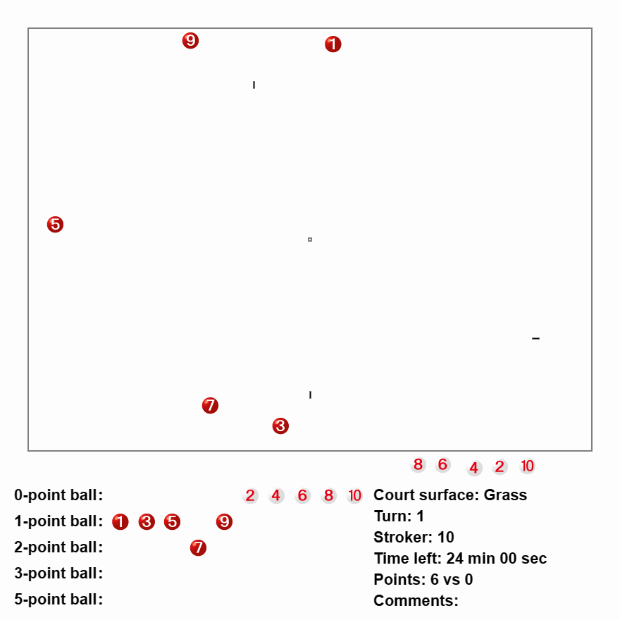

Ball 10 could set up in either blue position for Ball 2 to come on and slide towards either Gate 2 or Gate 3 and attack the balls there.

**Exercise: Example Opening**

Play out the above scenario for 10 minutes, playing to Ball 4 and alternating where Ball 10 is placed and note how many red balls can be taken off the court. Swap teams between red and white. **How easy / difficult was it to take out red balls**? **Which position worked best**?

Return to the lecture room.

***Maintaining control***

Things have gone well for white, with ball 2 taking off 3 and 7 and ball 4 taking off 1, 5 and 9.

Ball 5 to play. White now needs to maintain control ideally by clustering balls and ensuring Ball 10 can touch ball 2. A low risk approach is for Ball 6 to come on and spark Ball 10 to Ball 2, stay to help ball 8, with all white balls ending within touching distance of balls 10 and 2.

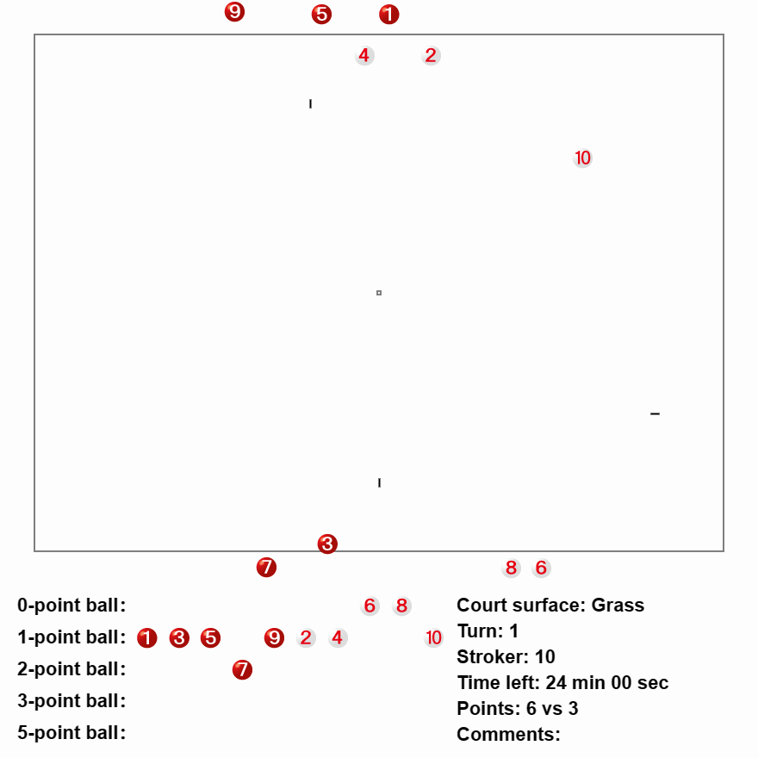

**Exercise: Maintaining control**

NOTE: The stroker here is BALL 5, not ball 10.

Play out the above scenario for 10 minutes, playing to Ball 4 each time. All red balls need to be either off court or under threat of being put off court [eg a white ball can come through a gate and then touch a red ball].

Remember white balls, you are not trying to score a lot of points at this stage – clusters are your friend!

Return to the lecture room.

**How easy was it to achieve? Would you have preferred any of the red balls to have been put out in a different location?**

***Last 5 minutes***

Now it’s about scoring points.

**Exercise: Last 5 minutes**

Red hasn’t really enough time to come back after 9, 1 and 3 are put out. Use this to your advantage and see how many points you can score in the last 5 minutes. Swap teams – highest white score wins!

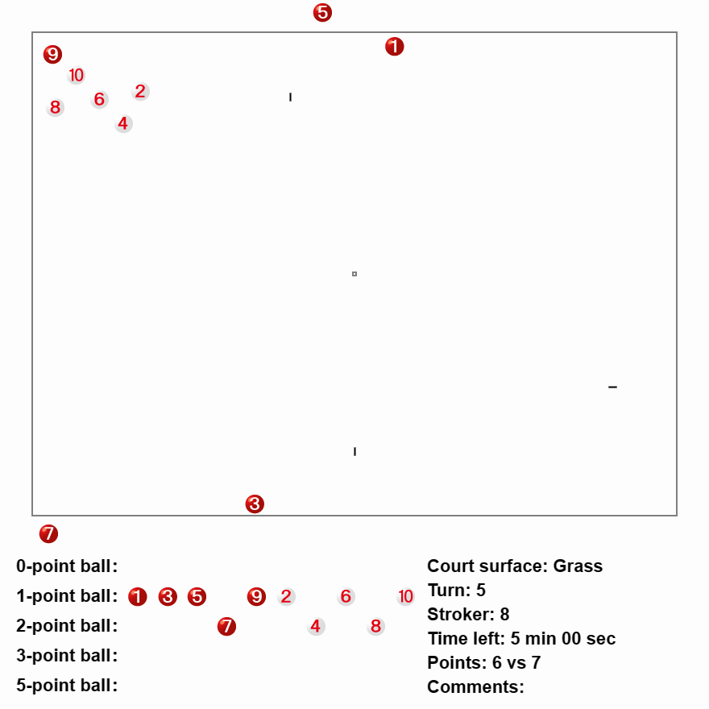

Fighting your way back [Glen]

**Aim**: Consider basic and advanced concepts of what to do when you have been knocked off the court by the other team.

**Basic Concepts**

DO

* Tap on, as close to the line as possible.
* Go help teammates/link balls when it is safe to do so
  + Look for any balls still to make gate 1

DON’T

* Make groups of balls when it’s not safe (beware of gate touches, linked balls)
* Go out too far onto the court

**Advanced concepts**

DO

* Tap on in pairs (link balls close to the line) if it is safe
* Predict what the opposition will do several turns ahead
  + Are their balls spread, are they able to link balls together
  + Are there any outballs
* Find you next ‘on ball’ and when it will be safe to go help that ball
* Consider the stage of the match to inform how much risk to take

DON’T

* Be too tentative, you are probably behind in the match so when there is an opening, go for it.

Any other DOs and DON’Ts?

Caveat: No hard and fast rules, you will need to adapt the approach depending on:

* Match score
* Time remaining
* Quality of opposition play and captaining.

**Activity**

Inside: The following two scenarios are similar. Play the following two scenarios out in your mind or on paper. Would you play the scenarios differently?

Outside: Play 2 rounds of balls (1-10) in the first scenario in pairs or triples (consider using non-playing captains). Was red able to come back?

Swap roles (captains and colours). Play 2 rounds of balls in the second scenario with two non-playing captains. Was red able to come back?

Did the two scenarios play out differently? Why?

**All Off - Scenario 1**

Red ball 1 to play and start working back into the match.

**All Off - Scenario 2**

Red ball 1 to play and start working back into the match.

**11 Training and the Triad**

**Practising all 3 skills**.

Gateball requires a triad of interlinked skills: individual, team and thinking skills. (Team skills include working with a captain)

Are you practising enough team and thinking skills if you do use block or random practice drills previously discussed?

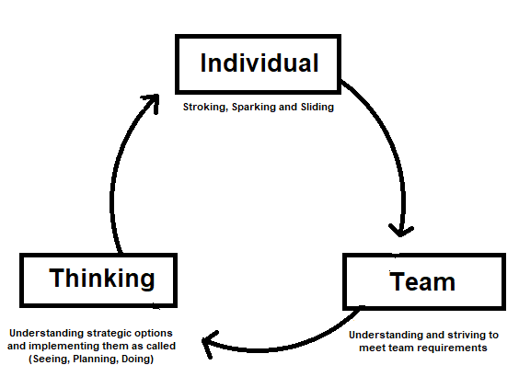

**The Action Perception Cycle**

1. Perception: players take in information from their environment, such as the location of balls, the current score in the game, the time left, their previous experience of similar situations
2. Decision-making: With a brief instruction from their captain, they integrate this guidance with their own perception and process all the information. They make decisions about how to execute their stroke or spark.
3. Action: Players then execute their chosen action, which in turn feeds back into their perception of what is possible in similar situations.

**Using Mini Scenarios for training**

If at the end, of a game, you can recall some situations that were important, they are worth replaying. Next time the situation arises a player is more likely to make the best decisions about how to play.

If a captain can obtain scenarios from other games, they can also be used to help the captain and player foster the skills needed by them both in order to work together.

**Advantages:**

* Players often prefer doing this rather than doing drills
* It provides opportunity for reflection relevant to game situations and feeds directly into player's experience. It thereby affects their decision making next time
* it can be more inclusive of “social” players

**A game is not practice, or is it?**

**Training and the Triad: Presenter**

The exercises for this session are *Mini Scenarios* that actually happened in real games. Participants need to use their individual skills, their team skills and their thinking skills to complete them. It is proposed that this can be a more rounded training activity than block or random drills.

A series of *Mini Scenarios* are included on the following pages. In the *Thinking Like a Captain Course* we have used mini scenarios to encourage players to think tactically about the strokes and sparks they are about to play.

As we are currently holding a Captain's course, we can use the following to address individual, team and thinking skills for both the player and captains!

Look through the *Mini Scenarios* and choose the ones that you think are the most interesting and start with those. There is no specified order for the activities.

**The steps you need to follow for each scenario are:**

1. Set the balls up as shown in the picture for the scenario you have chosen
2. Ask for a volunteer captain and player for each Mini Scenario
3. Ask your captain and player to move to a suitable position courtside but get the player and captain to stand apart.
4. Take the captain aside and show them the scenario or tell them what their strategic objective is for this turn. Don't let the player hear or see this! Tell the Captain and the player that they must not communicate until you call the player's ball! If they break that rule select another player!!
5. Explain to all assembled that you are going to assume the role of referee and that the Captain has a predetermined objective for this turn. Together, the Captain and player attempt to meet the objective of the scenario as if it were a turn in a game and following the rules..
6. Make sure you have your timer on your wrist. We are going to use the 10 second timer. In case you've forgotten, start your timer as you would for a game and then use the lower green button on the right to measure the 10 seconds. Make sure you test it out beforehand!
7. Move into position as the Chief Referee and call the player to stroke. Simultaneously, press your 10 second timer and continue to use it as the scenario is enacted.
8. If a time over foul is committed, replace the balls and ask another two players to assume the roles of Captain and player.
9. If a third attempt is necessary you can do so, or if you feel it is more appropriate to just discuss the scenario, do so.
10. Debrief each scenario:
    * + Inevitably people will want to discuss what the best thing to do would be. Let this happen
      + Ask what thinking the player is doing (the captain's notes have largely set their wider strategic thinking) How important is player thinking? Is there anyone who believes the captain does all the thinking for the team or is it shared leadership?
      + What team skills did the player and captain exhibit, what would they need to work at?
      + What individual skills did the player need and practice as they completed the mini scenario

**Final Debrief just before the end of the session.** What value can players see in replaying scenarios from games they have played. Does this mean that a game can be practice ( provided you reflect on it?)

**Training is a shortcut to experience A game is not practice, or is it**

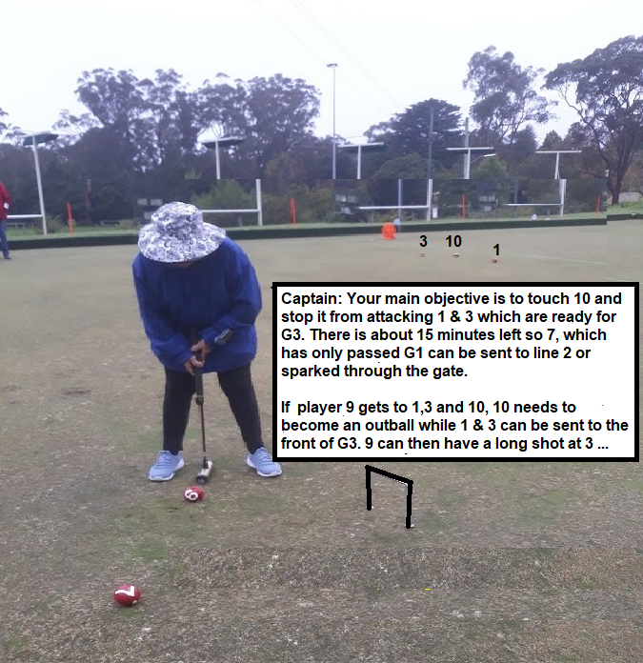**1**

**2**

Thanks Barbara N for providing this one!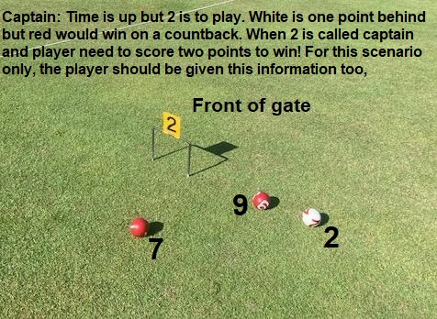

**3**



**4**



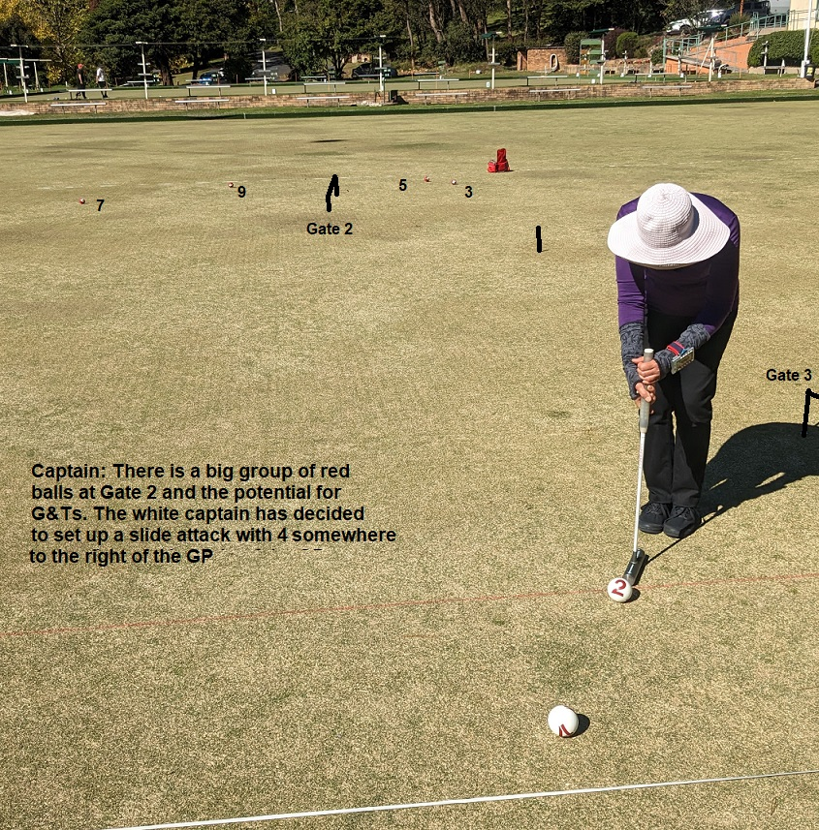**5**

**6**

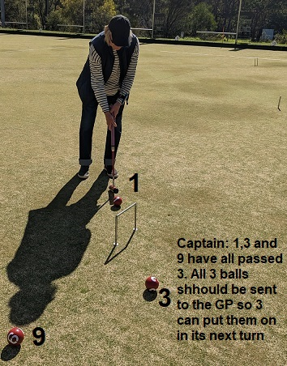

First 10 Minutes [Glen]

**Aim:** Consider different approaches to the first 10 minutes.

At this stage of the game:

* You can’t win the game but you can lose it.
* Control > points

DO

* Claim new zones of control
* Link balls (consecutive balls is most powerful)

Nice but not critical

* Spark your opponent off the court
* Score points

DON’T

* Create a target by clumping balls or straying too far from the lines
* Bring all your balls on in the first round

**Other tips**

Good to have standard opening approaches so your team knows what to expect.

How to play against a gate 1, gate 2 blitz.

Keep some balls off, stay calm, join the blitz if the payoff is adequately large (ie there are 3 or more balls behind gate 2).

How to play against staying off.

Take a zone or two of control, stay off.

|  |
| --- |
| **Opening Strategies for the Leading Team** |

|  |
| --- |
| **Gate 2 Side Strategy**  The traditional response is to place the first red ball very close to Line 2 but in a gate running position for the beginning of the second round. This standard opening is not used so frequently overseas. Increasing accuracy by the following team may result in this ball being attacked by incoming white balls.  Teams may increasingly decide to sit on or very close to Line 2, in line with the gate or up to a metre behind. A later ball may be placed in position for this ball to regain the front of the gate. |

|  |
| --- |
| **Gate 2 Side Strategy**  If Gate 2 is covered with one ball placed very tight to Line 2, a team may decide that another ball can be placed there too. Balls really tight to the line like this can carry out some powerful plays at the beginning of the next round. It was success with this strategy that lead to one of the two victories by Australian teams at an Australian Gateball Championship. |

|  |
| --- |
| **Placing a reception or connecting ball on Line 3**  If Gate 2 is covered by a ball in a gate running position, a later ball may be placed close to the middle of Line 3 so that the first ball can connect with it on passing Gate 2. This ball is then in position for the gate running ball to slide off or spark to another position. Some players refer to this as the Japanese position as this technique was usually employed by Japanese players who first came to Australia to educate players about the game. |

|  |
| --- |
| **Double Gate Grab**  Play a ball or balls to Gate 3 after placing a ball at Gate 2. This approach can be a counter to a team that aggressively attacks as the following team . The aggressive approach succeeds if balls pass Gate 2 after passing Gate 1. Teams that play this tactic to an extreme are said to be using “*Blitzkreig Stategy*” A Double Gate Grab is a means of countering this approach as balls at Gate 2 make it more of a challenge to blast through Gate 2 and then to blast through Gate 3. |

|  |
| --- |
| **Partial Holdback**  The leading team should also consider holding balls back after another strategy has been attempted with the opening two balls. This is especially the case where the following team is known to be proficient at using the holdback strategy. Balls that are held back can always be played in to slide off balls placed behind Gate 1. A ball sent as a pioneer or pivot ball can also be sparked where it can attack opposition balls or run a gate when a holdback ball enters a court. |

|  |
| --- |
| **Third Line Attack Strategy via G2**  Leading teams will often attempt this aggressive move especially with later balls. An attack is made on Gate 2 with the intention of the ball coming to rest near L 3. Control of the length of the Gate 1 pass should be considered so that the ball can either connect with another team ball on passing the gate or being in a position to be touched and sparked by another team ball that passes Gate 2**.** |

|  |
| --- |
| **Opening Strategies for the Following Team** |

|  |
| --- |
| **Second Line Edge Strategy**  The following team may decide to bring on ball 2 with a long cross shot and tuck really tight to Line 2 about 3-4m towards Gate 2. If this ball is not tight to the line, there is a good chance this ball will be made an outball by ball 3. If this happens, ball 4 can be held back and benefit from Ball 2 being played into a slide position at the beginning of the second round.  A possible result of this play is that there is an attack by red 3 on white 2 which misses. This can leave a two ball target for ball 4. Ball 4 enters play with a long cross shot, touches on of these two balls and cleans out the opposition at Gate 2. |

|  |
| --- |
| **Third Corner Swift Attack Strategy via G2**  Teams will often attempt this aggressive move. A controlled cross shot through Gate 1 will finish in a position where a long shot at Gate 2 will sometimes pass Gate 2 but at least end up in a defensive position in Corner 3 or tight to the far end of Line 2.  If Gate 2 was run, this ball can sometimes attack red balls at Gate 2, tuck in near the line or move to gate 3 to adopt a position where its path through gate 2 can control the area behind gate 3. Possibilities open up of being able to set up a gate touch or post gate slide for this ball  Some teams will aggressively attack Gate 2 with most of their balls after passing Gate 1. This is sometimes referred to as the *Blitzkreig Strategy.* Of the strategies referred to in this document, this strategy has had the least success when playing overseas teams. |

|  |
| --- |
| **Take 3**  Many Australian teams have previously placed their first and second white balls at gate three. Originally these were placed just in front of Gate 3 and tight to line 4. Others prefer placing the balls between the gate and line and some migrate to a position behind the gate. During the second round, these balls were used to set up an aggressive slide to attack red's control of gate 2 or, at some point, an opportunity may arise to spark a ball over to Gate 2.  Placement of balls 2 and 4 together in order to mount an attack can be set up in other parts of the court instead of at Gate 3, for example:  -Playing a short reverse cross shot towards line 1 Ball 2 is then played into corner 1 in an effort to group at least two balls together (2,4.) This can be highly effective as it is the largest distance that can be created between the white balls and the red balls at Gate two. This strategy is used best against a team which is highly defensive as they are unlikely to attempt to go through gate 1 and attempt to attack balls in front of Gate 1  A riskier approach is playing to Corner 2 – A long reverse cross shot through Gate 1 can position the ball in Corner 2. Playing the ball extremely close to or on the line in corner 2 is highly effective against more offensive teams. Playing a ball to this corner will allow for the 2 ball to have a relatively straight shot at Gate 2 before ball 3 plays This can be an advantage if it can be run with control to take advantage of a misplaced ball 3 if it so exists. |

|  |
| --- |
| **Partial Holdback**. Applies to following team too |

**Activity: Round 1**

You are playing red against a strong international team. Mark on the paper where you would ask ball 1 to go. Now pretend you are playing white against a strong international team and mark where you would ask ball 2 to go. Continue for the first round. Compare your results with others.

Try outside. The first pair/triple place ball 1 where you would like, the second pair place ball 2, the third pair place ball 3 etc. After all 10 balls have been placed play out round 2 (balls 1-10) and observe how the game played out. Could you have improved your placement of balls after round 1? Chart

**Glen’s favourite opening**

Play out round 2, one ball at a time on paper. Assume reliable solid play but not achieving low percentage shots (eg making a gate from 10m). Which team finishes the second round in the better position?

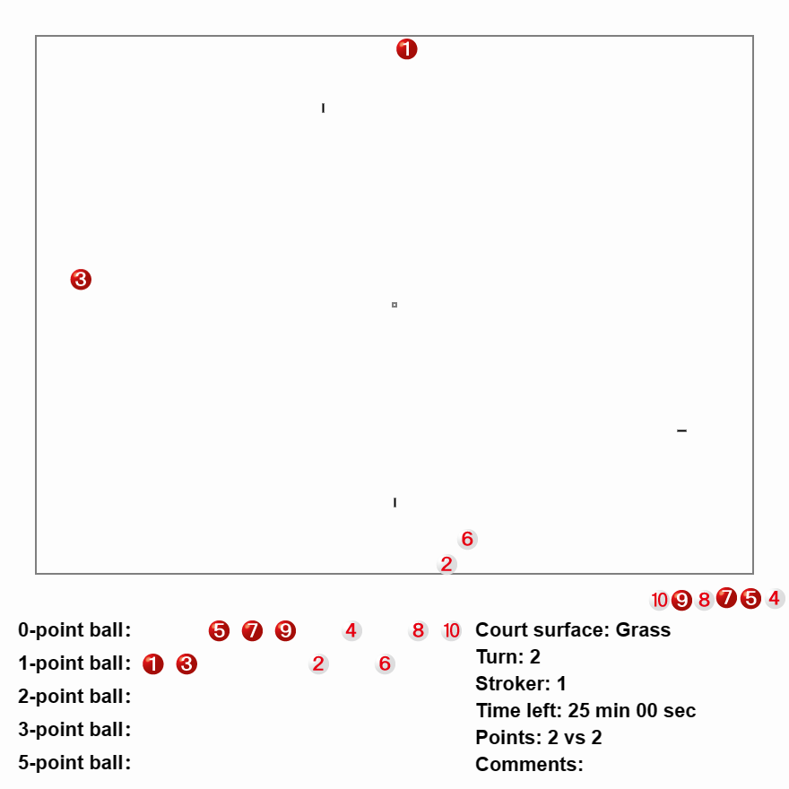

Middle 10 Minutes: When to abandon Gate 2 [Geoff]

**Aim: To consider the best point in the game to give up control of Gate 2.**

**Basic ideas:**

* Control of Gate 2 prevents your opponent from setting up near Gate 2 and scoring points or setting a Gate - Touch, whilst allowing your team to make controlled point scoring or possibly set up a Gate - Touch.
* The question arises during a game of when to move on from Gate 2 to try and score points at Gate 3.
* It is likely that your opponent controls Gate 3, but is trying to control Gate 2.
* Usually it makes sense to retain control of Gate 2 until all or most of your balls have scored it and you can attack Gate 3 with say 10 minutes left. At this stage you should be 4 or 5 points clear.
* You may be able to move earlier if you can easily retake control of Gate 2 – eg outballs allow an attack or you can set a Gate – Touch at Gate 3.
* It is not ideal to try and control Gate 2 with a ball that has already made Gate 2

In the scenario below, red has moved away from Gate 2 with 3 balls and these have all scored Gate 3, and so there is no possibility of setting a Gate – Touch.

Ball 1 has scored 2 points and ball 7 has scored 1 point. Between them they “control” Gate 2, or do they?

Red is 12 – 5 ahead. Which balls would you prefer to play and why?

**Exercise – Play out the scenario, once as red and once as white, Ball 1 to play.**

**Who won? Was it wise for Red to leave Gate 2 and score Gate 3 with 3 balls?**

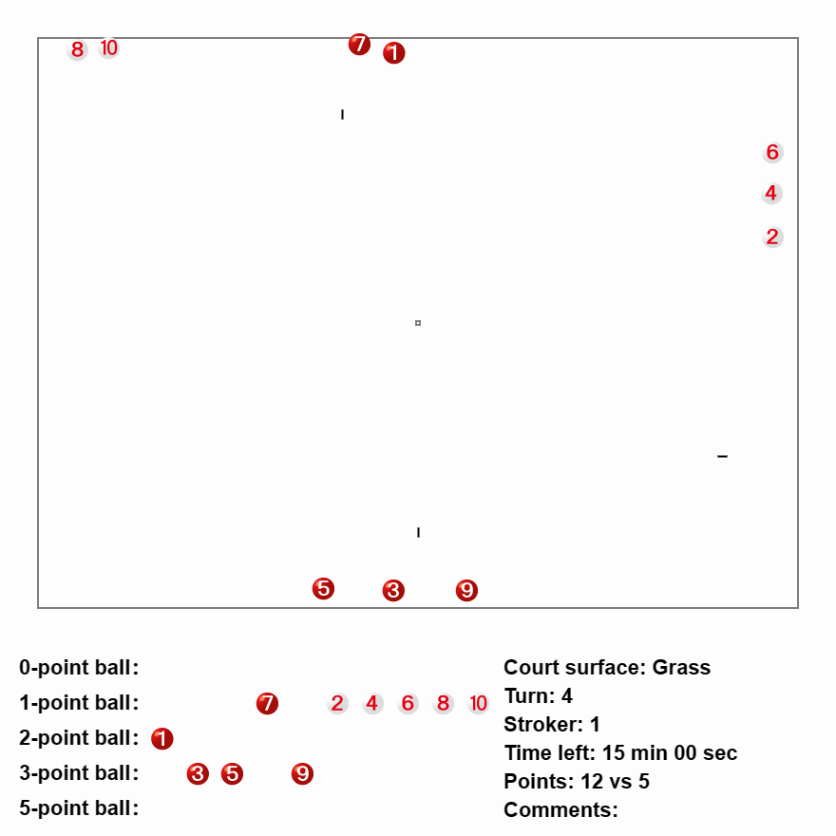

Final 10 Minutes: Managing the here and now [Philip]

There are no prizes for being in a good position at the call of “Game Set”.

**Guiding Principle: There are three elements to a win**

Mechanically, how do you win a game of gate ball? There are three elements.

When my team, has more points than your team, at the end of the game.

This means there are thee things you can affect to win a game.

1. Your own team’s score (play attacking).
2. The other team’s score (play defensive).
3. Exactly when in the order of balls the game ends (time management).

**Guiding Principle: Probabilistic Gateball is still at play – but the costs and payoffs are different**

Still analyse probabilistically, but remember, in the last coupe of minutes the analysis is very different. It’s all short-term.

The “cost of failure” might be nothing. Got a ball with no chance of scoring the gate? Well, it’s not going to play again. This applies to your own balls that you’ve touched too. Bombard with your own ball if that’s the best choice.

Try the maverick shot– but be wary of leaving stepping stones for the opposition. (Remember the drill, “How do you shoot the devil in the back?”)

This applies both ways, of course. If an opposition ball is touchable, that doesn’t mean you should. Do you need to touch that ball? Would the last minute be better spent scoring points for your own team? With a minute to play, there’s not a great deal of reason for Ball 1 to touch ball 10. Ball 10 won’t play again. If you want to bombard Ball 2, then go ahead, but make sure the payoff is immediate.

**Guiding Principle: Decide which ball you want to end the game with, and play accordingly.**

If you want to play slowly:

* Communicate to your team that you need to play slowly!
* Within reason, take your time. Wait for the 8 count if you want.
* Touches are your best friend. You can burn a lot of time if you deliberately take 8 seconds, touch the first ball, take 8 seconds, make the spark, take 8 seconds, touch the second ball, etc.
* Deliberately hitting a ball out of bounds, diagonally across the field, can use a lot of time. The perfect ball just rolls out of bounds in the last 10 centimetres.

If you want to play quickly:

* Communicate with your team that you need to play quickly!
* Give instructions before your player is called.
* Do only what you must. Ignore distractions or other balls that could be touched, but don’t need to be.
* Tap balls on the head if there’s nothing to be gained from playing them.

**Scenario: Make every second count**

You are the Red captain. What do you tell your team to do?

Start with an opposition analysis. Who’s winning? What are the threats?

Task 1: Outline the best strategy for white

* Clearly, balls 6 and 8 are out balls, so they’re not going to score. However, ball 10 is live and very hard to reach. It is a serious risk
* The best result for white is:
* Ball 6 about half way between Ball 10 and the gate 3.
* Ball 8 just in front of ball 10, to allow the rush to Ball 6.
* IF BALL 10 PLAYS, it can then touch 8, spark to the pole, touch 6, through gate 3, 10 through gate 3, then a shot at the pole itself. Ball 10 has 6 points available.
* Ball 2 has a point available too if the balls play quickly.

Task 2: Outline the best response for red:

Clearly ball 5 should touch ball 7. But how? What next?

I want at least three possible strategies suggested from the floor for the red team here.

Outline the positives and negatives for each placement.

**At the goal pole**

Pros:

* 2 points, maybe 3. If you leave 7 near the pole, the 2 points are near guaranteed.
* Ball 5 can rush off the right of 7, making the shot on Gate 2 easier, though far from guaranteed.

Cons:

* Leaves white unmolested to score as many as six points.

**As close as possible to Ball 10**

Pros:

* May be able to knock ball 10 out. Seems unlikely a touch could be made. Deprives white of 6 points – perhaps. Might block ball 6 from coming on too close to ball 7. But if 7 misses 10, then 8 still comes on as the rush ball.

Cons:

* Leaves a possibility that ball 2 will play, even if 7 successfully touches 10.

**Commence time wasting tactics! Down into the cluster near gate 1.**

Pros:

* RED ARE CURRENTLY AHEAD. If time can be used up before ball 8 plays, then red win.

Cons:

* It’s a little underhanded. But if executed properly, there’s no way for white to win.

The full strategy:

1. 5 touches 7, rushes off the left-hand side towards ball 4.
2. 5 sparks 7 just past the cluster at gate 1.
3. 5 touches 4, rushing towards the cluster also, if possible.
4. 5 sparks 4 past the cluster to 7.
5. 5 attempts to touch 1 or 3, without going far past the balls.
6. 6 comes on? Might touch on head.
7. 7 touches 4.
8. 7 sparks 4 out. Bombard at Ball 10!
9. 7 touches 5.
10. 7 sparks 5 at gate 2, hard (misses, becomes out ball).
11. 7 touches 1.
12. 7 sparks 1 at gate 2, hard (misses, becomes out ball).
13. 7 touches 3.
14. 7 sparks 3 at gate 2, hard (misses, becomes out ball).
15. 7 shoots at the pole, hard (misses, becomes out ball).

If each shot is played after 8 seconds, and the shot itself takes 4 seconds of ball movement, on average. Then this will use at least 14*12 = 168 seconds, probably more by the time the balls are set as out balls. That’s more than enough time to run out the game, even if white tap 6 on the head. Add in some referee time walking between balls and you’re going to win.

Red may even score some points. None of the scoring attempts is particularly likely to succeed, but there are four low-probability attempts. Might score one or two points.

Game set.

Red wins 9-9 on countback.

Court Exercises:

Play out the scenarios suggested.

# Self-Reflection, part 2 [Court Leaders]

Play a game, 3v3 on each court.

Try to play MINDFULLY. Remember the concepts we’ve been talking about the last few days. Analyse the opposition and communicate amongst your team.

Everyone here can captain, the best teams will get the most out of everyone.

Once you’ve finished, stop and ask yourselves these questions:

Did the team that was better at hitting the ball win?

Why did the team that won, win?

Accuracy?

Strategy?

Luck?

What were the key moments of the game?

What captaincy techniques were used?

What would you do differently if you had your time over?

Did you notice a difference between the first one and this one?

Blitzkrieg and how to beat it [Philip]

Blitzkrieg as a play style is often alluring when teams are getting better. Basically, rather than play positionally, teams prioritise scoring at every opportunity.

It can score some impressive wins in the short-term, but is unlikely to work in a sustained way. Blitzkrieg is the ultimate elevation of **space** at the expense of **order.**

The way to beat blitzkrieg essentially boils down to: watch the numbers and take your opportunities. Taget the otherteams balls, then target your own points.

A team playing to prioritise scoring will leave gaps and create clusters. To defeat blitzkrieg try to make sure as many as possible of your balls have consecutive touches available.

Court Exercises:

**Scenario: Blitzkrieg and surgical strikes**

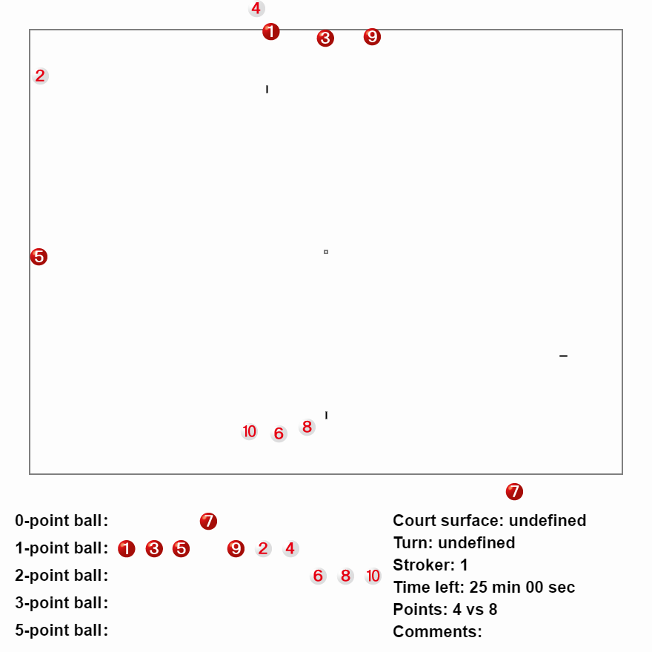

Ball 1 to play. Keep your cool. Take control of the game.

Red has positioned fairly well here. Pick your moment. You might have to play the percentages.

**Scenario: Blitzkrieg and surgical strikes**

Guidance:

There are two possible scenarios here – do you play percentages and send 3 to 6, or try to touch 3 onto 5.

The key point here is that blitzkrieg will create disjointed balls. Notice that the red balls are connected. 1 can touch 3. 3 can touch 5. 2 and 4 are isolated.

You have to make your move at the right time. If you let 6 play, it probably sets a gate-touch for 8. That’s bad.

Should you send 3 to the cluster or 5? I would send 3 and abandon the point… 2 is going to shoot for the cluster regardless. And although 3 can touch 5, it’s not a given.

Once you have control of the court, use clusters to score points quickly.

**SECOND EXERCISE:**

***3 Turns, 10 Points.*** *Place all 5 balls from one team in a cluster in font of gate 2. You have 3 turns to score 10 points. It’s relatively easy conceptually – just use ball 1 to spark all the balls through to a similar depth. Use Ball 3 to spark them all over in front of gate 3. Then ball 5 to spark them all through gate 3. If ball 5 manages to agari afterwards, it’s actually 12 points…*

Conclusions [Philip]

What a weekend! I hope you enjoyed yourselves.

The materials used for this weekend will be made available on the Gateball website.

What we learnt:

* To analyse a Gateball situation.
* To think about the game in terms of **space** and **order**.
* To communicate with out team members.
* To respect each other and lead with humility.
* To train ugly to get the best out of the training time.
* How to play attacking Gateball and d0efensive Gateball.
* How to treat the three phases of the game differently.

Thanks very much to

* The ACA for providing the funding for the weekend.
* The council which provided the grant.
* The Court Leaders
* Ros Crowe
* Everyone who came – the best way to improve gateball is to teach each other what we’ve learnt.