2023 Captain’s Course
Attendee’s notes
Held 20-21 May 2023, at Eildon Croquet Club

Better Captains Making Better Teams

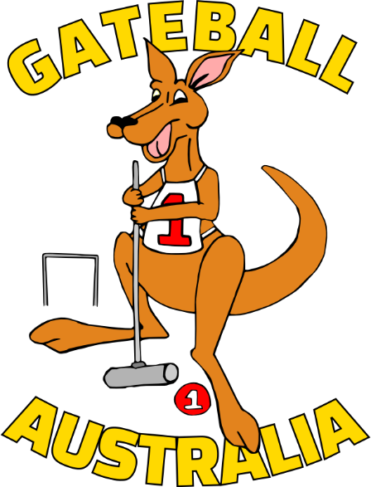

Train Ugly? Training Techniques to Promote Success for Your team

Practice

Block: same action again and again...vs...Random: building in some variety
Random Practise makes you read, plan, do. Practising Skill Sequences is the ideal way to go for GB
Reviewing some past practice
Dates | Programs | Block | Random | Tallied? | Motivates?
2006 | Keith McLeod. 100 balls through G1 every day!  Gateball Information Pamphlet No 6 (gateball.com.au/Coaches Corner/ Gateball Information Pamphlet 005 Practice Routines
2009 | Qld State Team practises, trains and competes at the 2009 AGC
2010 | Gateball Skills Carnival -(gateball.com.au/Coaches Corner/Basic Drills/Skill Cards and Programs to use)
2011 | Wagga Wagga's TRAC School team learn, train and compete in the 2017 AGC. (gateball.com.au/Coaches Corner/Basic Drills/Introducing Gateball to Groups...)
2015 | ACA Coaching Program for the Foundation level: GB Basic Skills Card (gateball.com.au/Coaches Corner/Basic Drills/Skill Cards and Programs to use)  Gateball for Beginners Skills Cards (gateball.com.au/Coaches Corner/ Gateball Information Pamphlet 016/p12
2019 | CNSW PPEP Program based on AIS FTEM framework  Gateball for Competition Players (gateball.com.au/Coaches Corner/ Gateball Information Pamphlet 017/ Gateball for Competition Players)
NB All but the 2009 item referred to above are available on www.gateball.com.au. As the site undergoes some changes you may have to search in “Coaches Corner”

Activities. With your session leader:
Use some of the activities in “Gateball for Competition Players” and consider their potential to enhance players' ability to play “Skill Sequences.”
Map where your “ usual team” is placed on the FTEM framework. Write initials in the table. Discuss how you can “train” your players given that they are at different places on the FTEM framework.
FTEM MODEL & GATEBALL
FTEM LEVEL | CRITERIA | GATEBALL SKILLS | SUPPORT
MASTERY  Sustained Success | • Repeated international podium success over multiple years | Oustanding individual, team and thinking skills | High Performance Manager
ELITE 2  Success | • Podium success at a major international event  • Demonstrated team leadership and personal excellence | Oustanding individual, team and thinking skills | High Performance Manager
ELITE 1  Representation | • Selection to national teams  • Progression towards World Class performance standards | Individual, team and thinking skills of a high standard | High Performance Manager
TALENT 4  Breakthrough & Reward | • Achievement of a breakthrough performance and/or reward | Undertakes skill sequences with frequent outstanding plays  Important part of team leadership structure/Captains  Referees | Level 2 & 3 Coaches, Captain’s Courses, Gateball for Competition Players, High Performance Manager, Resources on GA website
TALENT 3  Practising and Achieving | • Increased investment in practice and competition.  Attends State & Australian Championships and participates in triples and doubles | Undertakes skill sequences with occasional outstanding plays  Part team leadership structure/captains  Referees | Level 2 & 3 Coaches, Gateball for Competition Players, Captain's Courses, High Performance Manager  Resources on GA website
TALENT 2  Verification | • Verification of talent & potential during training and interclub and more challenging competition  • Initial exposure to high performance training | Competently undertakes skill sequences  Develops good team and thinking skills  Captains, at least in social games  At least a Referee in Training | Level 2 & 3 Coaches, Gateball for Competition Players, “Think Like A Captain Course,” Resources on GA website, Beginner Captain Courses, High Performance Manager
TALENT 1  Demonstration of Potential | • Initial demonstration of talent in competition & potential for development  • Expression of interest to expand ones knowledge and skills | Reliable basic individual skills & team skills  Refereeing team roles  Further develops thinking skills – can see options. May captain socially. | Level 2 Coaches, Gateball for Competition Players, “Think Like A Captain Course,” Resources on GA website, Beginner Captain Courses
FOUNDATION 3  Commitment/ Competition | • Training & skill development  • begins involvement in competition | Competent with basic individual skills & team skills. Self corrects routines.  Develops thinking skills | Level 1 Coaches, GB for Beginners  “Think Like A Captain Course”  Basic Skills Cards
FOUNDATION 2  Extend & Refine Movement | • Initial introduction continues  • Recreational involvement in club games | Applies routines to basic individual skills  Develops team skills | Level 1 Coaches, GB for Beginners  Basic Skills Cards, Satoshi's Videos
FOUNDATION 1  Learning and of Basic Movement | • Acquisition of fundamental movement skills (Routines)  • having fun | Introduction to GB  Develops routines for stroking, sparking and sliding | Level 1 Coaches, GB for Beginner
Draft May 2023§
11 Training and the Triad

Practising all 3 skills.
Gateball requires a triad of interlinked skills: individual, team and thinking skills. (Team skills include working with a captain)
Are you practising enough team and thinking skills if you do use block or random practice drills previously discussed?

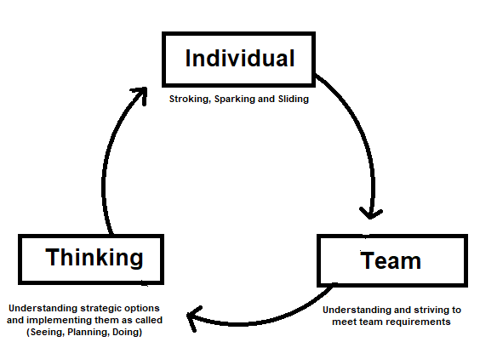
The Action Perception Cycle
- Perception: players take in information from their environment, such as the location of balls, the current score in the game, the time left, their previous experience of similar situations
- Decision-making: With a brief instruction from their captain they integrate this guidance with their own perception and process all the information. They make decisions about how to execute their stroke or spark.
- Action: Players then execute their chosen action, which in turn feeds back into their perception of what is possible in similar situations.

Using Mini Scenarios for training

If at the end, of a game, you can recall some situations that were important, they are worth replaying. Next time the situation arises a player is more likely to make the best decisions about how to play.

If a captain can obtain scenarios from other games, they can also be used to help the captain and player foster the skills needed by them both in order to work together

Advantages:
- Players often prefer doing this rather than doing drills
- It provides opportunity for reflection relevant to game situations and feeds directly into player's experience. It thereby affects their decision making next time
- it can be more inclusive of “social” players

Probabilistic Gateball – Part 1 [Glen]

Aim: As a captain you consider the likelihood of your teammates and opponents making certain shots.

This exercise will quantify the success rate of certain shots.

In a match we get feedback from the success of a shot with a small sample size, often a certain shot will only occur once in a match. Collecting a larger sample will give a more accurate indication of the chance of success (for our group of participants, on a given court, on a given day).

In this exercise we will record our predictions, discuss the rationale for these predictions, refine our prediction and compare with others and the actual results.

Certain captains may have optimistic or pessimistic predictions which could be considered when improving your captaining.
Shot | Predicted Chance of Success (%) | Average prediction  (%) | Predicted chance of success after discussion (%) | Average prediction  (%) | Actual (%)
2m ball touch
4m ball touch
6m ball touch
11m touch from behind gate 2 to a ball in front of gate 3 (single ball)
11m touch from behind gate 2 to two balls in front of gate 3 (balls are one ball width apart)
Gate 1 and then gate 2
Angled gate from border on 45° (2.8m shot)

Probabilistic Gateball – Part 2 [Geoff]

Aim: As a captain you consider the likelihood of your teammates and opponents making certain shots, and the risks of failure compared to the rewards of success.

Glen has taken us through an exercise that provides some clarity regarding the ability of players to make certain shots.

This module will put that in to practice by looking at a game situation, which will also introduce the concept of risk/reward – ie what are the consequences if your player stuffs up?

Expected Key Learnings
- Strategy needs to be matched to the team’s skills.
- Best way to improve results is to encourage team to improve skills. Improved skills opens up many more viable strategies.
- Each shot has a risk/reward attached, based on each player’s ability. Assessing these is key to success.

Consider the situation below:
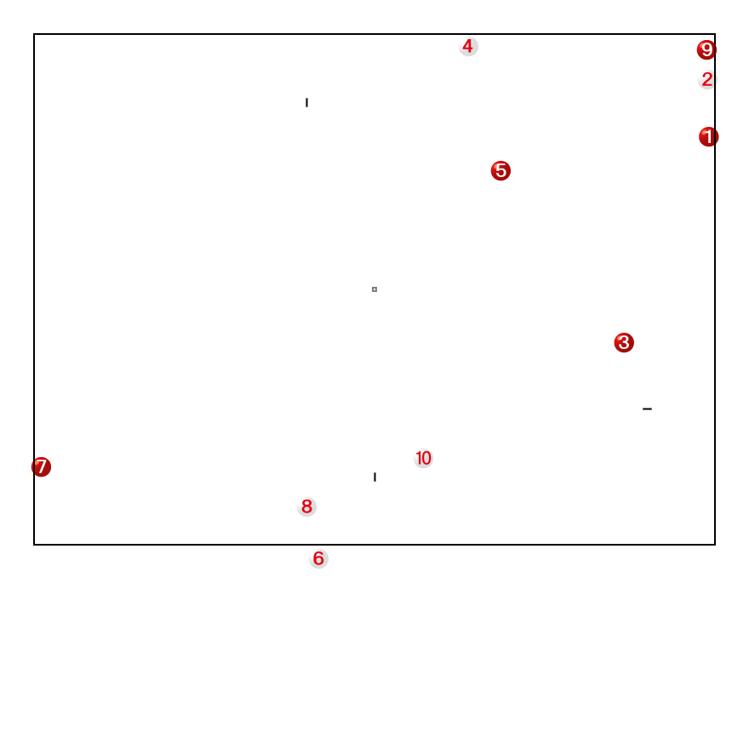
All balls are for Gate 2 except Balls 7& 8, which are for Gate 3. Ball 6 is an Out Ball, and Ball 3 is closer to Ball 10 than Ball 5. 15 minutes remain. Ball 8 has a gate touch on Ball 10.
Ball 3 is to play.
Questions:
- Identify strategic problems for red:
- Discuss options for Ball 3 to neutralise identified threat(s)
- Would your answer change if Ball 4 was in NW corner [corner 3]

Discuss options with the group – then go and try it

Humility and Leadership [Barbara]

For this small, introductory segment you have a piece of paper called “Leadership in Gateball” on which there are three columns. One is listed as Always, one is listed as Sometimes and one is listed as Never. You will work in pairs. Please be prepared to debate your answers with a person in the group who is not well known to you thereby debating with someone who may have differing ideas. Then, Place a Tick in the column that represents your own opinion.

People are different as we all would agree. But the important
Behavioural Characteristics of effective Captains are as follows.

For Gateball Captains it is essential for the Captain to be
- Dedicated to the role
- Hard working at own skills
- Focused on all the members in the team
- Unselfish and humble
- Strong in self- esteem and confidence in his/ her knowledge of the game and their own ability
- Respectful at all times of the opposition players, referees, officials of the Gateball Community and those officials at State and National level.
- Are very good role models.
- Accept personal responsibility for own actions.

I am going to share with you an item in the Business Section of “ The Australian” newspaper. It is writing about business leaders but is just as relevant to sports leaders and Gateball Captains as well.

In addition to the behaviour characteristics of a good leader or Captain in the Gateball environment that I have been outlining, there are skills that will ensure the effectiveness of a Captain.

Below are Leadership Skills that are crucial to the success of the team.

1. Interpersonal Skills are critical. A Captain of a team builds relationships within the team members, understands how to develop the players to their maximum of abilities, and creates a unity of purpose.

2. Communication skills are another of the essentials that a good Captain requires. It is having the understanding of and the ability to adapt the message to the situation for the individual team member.

3. Knowledge of the game is a skill that has evolved and developed over time. An effective Captain has ‘studied’ all aspects of the game; the various strategies that are most suitable for the team as well as for the individual team member; and continues to study the game and it’s intricacies.

4. Decision making is another critical aspect of being a successful Gateball Captain. Being cool under pressure is an absolute ‘game changer’ for an effective Captain. This skill will be developed over time but it is also an inherent quality of the person who aspires to be an excellent Captain. Whether a person is an extrovert or an introvert, the credibility of a Captain requires calmness in a stressful situation.

5. Mentoring and support of all team members will be a necessity in the creation of a successful team so these coaching skills are another critical asset for a Captain. Analysing and identifying the perceived problem areas of a team member’s skill set will ensure a better performance by that player.

6. Inspirational skills are highly valued in a Captain’s repertoire if he/ she is to be able to enthuse the team and foster the highest standard of behaviour of the team members. Establishing a very good sporting culture within the team is the hallmark of a top quality Captain.

7. Self Awareness will ensure effective leadership. The Captain’s self-awareness of his/ her personality style and leadership style encompasses the myriad of decisions that are required. A great Captain understands their own strengths and limitations as well as their own motivations.

Leadership in Gateball

Statement | Always | Sometimes | Never
#1
#2
#3
#4
#5
#6
#7
#8
#9
#10

News item from the Business Pages of “The Australian” Newspaper ,
May 6-7, 2023

“Humility goes to the heart of great leadership, according to the head of global executive think tank, ‘The Leadership Circle’, Mark Burrell, who says these kinds of leaders are consistently rated as decisive, visionary and purposeful, with a ‘connection to something bigger than the personality of the leader.’

‘Leaders lacking humility are often invested in their own sense of rightness, although this can be hard for them to acknowledge’, says Burrell. ‘This kind of leadership has pay-offs to be sure, but the downside is the inability to take in discomforting information and the tendency to create a culture of certainty and arrogance.”

(The item referred to a woman who was announced as being the new Chief Executive of Qantas.)

Communication: Giving and Receiving Information [Philip]

Giving information clearly. You only have 10 seconds!
While you can give information only in terms of what the shot should be, if a player understands why the shot is being made, they will often understand better – and faster. For example.
“Hit the ball about 75cm in front of gate, at a 45 degree angle back towards the line.”
Or
“Gate 2 straightener for Ball 3”

This requires all players on the team to have a common Gateball language. This will include names for both physical places on the court and for game concepts.
This needs to be practiced inside clubs before competitions. However, it would be better for Australian Gateball if the various teams had as much cross-over as possible. This will make combined teams more cohesive. Are there any other places your team gives a name to?
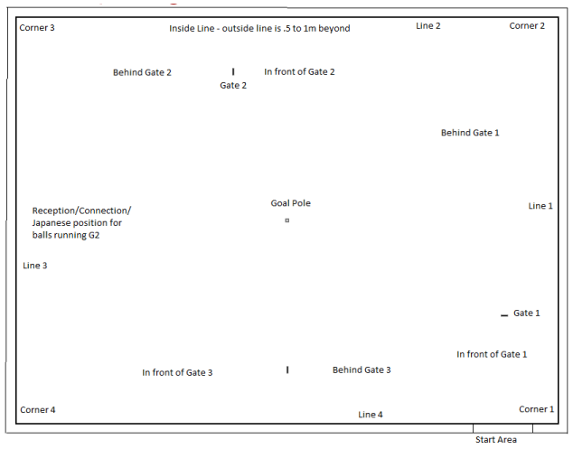
“Japanese” position has fall out of use now. “Reception deep behind Gate 2” is probably better.

Notice that behind gate 2 and gate 3 are straight behind. Behind gate 1 assumes the normal gate 1 angle. I

“In the jaws” – which means just behind the dead centre of the gate. Essentially makes any gate a gate-touch.

Names for common Gateball concepts:
- Gate-touch – passing the gate then touching another ball.
- Touch-gate – touching another ball and then passing the gate. Called an “In-off” in Golf Croquet.
- Slide / rush – a ball to allow another ball to deliberately nick off the side and change position.
- Straightener – a ball deliberately placed in front of a gate to allow another ball to improve their angle on the gate.
- Guard - deliberately placing a ball on a 45 degree line to the gate near the sideline.
- Cluster - a group of balls. Normally at least 3.
- Ladder/bridge/chain – a line of balls allowing one ball to cross considerable distance in multiple short moves.
- Bombard – deliberately using a spark to force another ball out of bounds.
- Push Out – deliberately touching a ball and knocking it out of play, even if both balls become out balls.
- Wired – When two balls which are relatively close can’t score a touch against each other because there’s something in the way (normally a gate – also the goal pole).
- Tight to the line – leaving a very ball very near the line so it’s hard to touch.
- Edge on – Come on to the field as an outball, but as close to the line as you can.
- Blocking Ball – Placing an on-ball just in front of an out-ball to precent the outball edging on.
- Three ball gate-setup – A set of three balls. Two in front, one behind, to allow a gate-touch.
- Attack Ball – A touch which allows the touched ball to be moved to a more attaching position.
- Shield Ball – A ball which prevents an attack ball.
- Holdback - deliberately not coming through gate 1 as a tactical decision.
- Tap on the head – deliberately touching a ball on the top and leaving it in place.
- Right in front of the gate vs Hide near the line – To distinguish how far out from the line you want the ball.
- Pivot – a ball placed behind Gate 1 to allow balls to slide towards gate 2.
- Peel – deliberately pushing a ball through a gate on the “touch” part of the shot, allowing a spark afterwards.
- Large Pole – “Make the pole larger” – Placing a ball near the pole as the target rather than the pole itself.

Any other names or concepts you use in your team?

Receiving Information
All the players on the team can be useful sources of information and ideas. Ask them. When you are playing at your club, encourage them to speak up.
Receiving information is particularly important when your ball is about to play, but you want to know information about the far side of the court. When you have common language this is much easier.

Fighting your way back [Glen]

Activity
Inside: The following two scenarios are similar. Play the following two scenarios out in your mind or on paper. Would you play the scenarios differently?

Outside: Play 2 rounds of balls (1-10) in the first scenario in pairs or triples (consider using non-playing captains). Was red able to come back?
Swap roles (captains and colours). Play 2 rounds of balls in the second scenario with two non-playing captains. Was red able to come back?
Did the two scenarios play out differently? Why?

All Off - Scenario 1
Red ball 1 to play and start working back into the match.
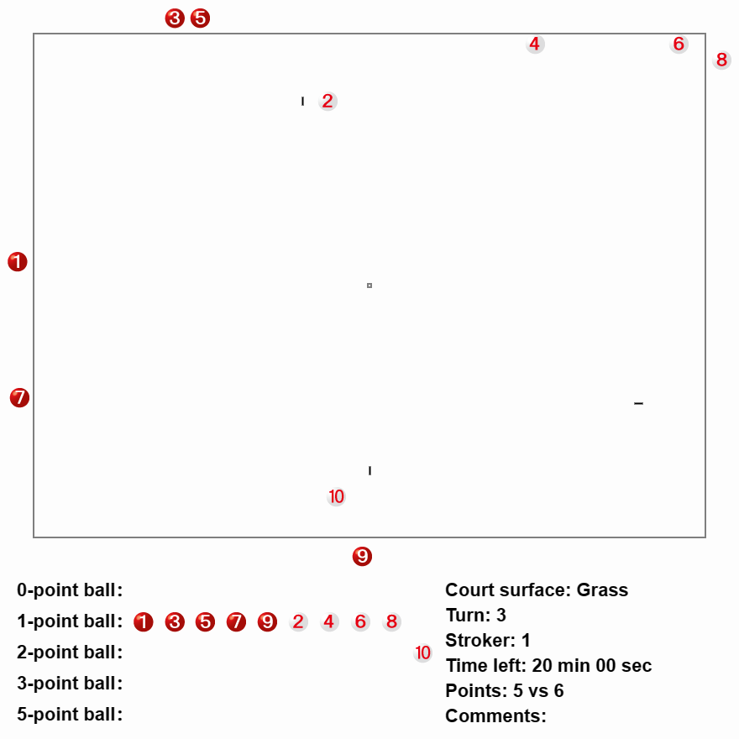

All Off - Scenario 2
Red ball 1 to play and start working back into the match.

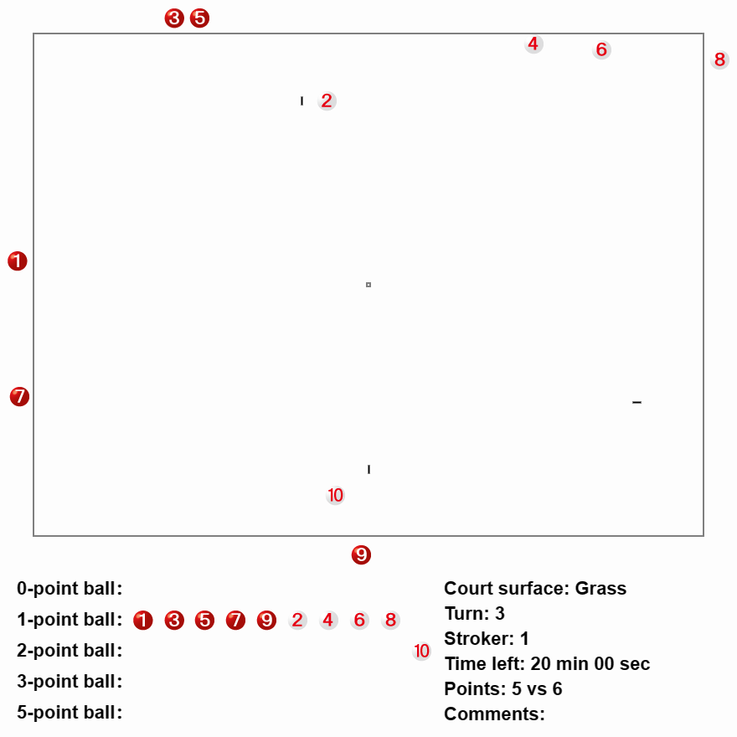

First 10 Minutes [Glen]

Activity: Round 1

You are playing red against a strong international team. Mark on the paper where you would ask ball 1 to go. Now pretend you are playing white against a strong international team and mark where you would ask ball 2 to go. Continue for the first round. Compare your results with others.

Try outside. The first pair/triple place ball 1 where you would like, the second pair place ball 2, the third pair place ball 3 etc. After all 10 balls have been placed play out round 2 (balls 1-10) and observe how the game played out. Could you have improved your placement of balls after round 1? 