ANNUAL GATEBALL FUN WEEKEND
5th & 6th July 2014

Saturday ~ Teams – Round Robin
(Teams can be arranged for those that don’t have enough players)

Sunday ~ Rotating Doubles – partners drawn
(2 people may enter the doubles as 1 player and just play alternating games)

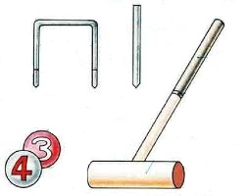
Entry Fee: $10 per person

Closing Date: 7th June

Morning and Afternoon Teas provided
Lunches will be available for purchase
Saturday Social Dinner Night tba

Team Name: _____________________________________ Doubles (yes/no)
Player 1: _____________________________________________ _______________________
Player 2: _____________________________________________ _______________________
Player 3: _____________________________________________ _______________________
Player 4: _____________________________________________ _______________________
Player 5: _____________________________________________ _______________________
Player 6: _____________________________________________ _______________________

Entries may be copied and emailed to Tournament Manager with direct transfer of fee:
BSB: 650 000 A/C: 952962418 Details: GB +name
Tournament Manager: Kerrie Sutherland jrskls@bigpond.com
Or mail with cheque (payable to Newcastle National Park Croquet Club Inc)
By 7th May to Hon Secretary, PO Box 2052 Dangar NSW 2309

