SOUTHPORT CROQUET CLUB

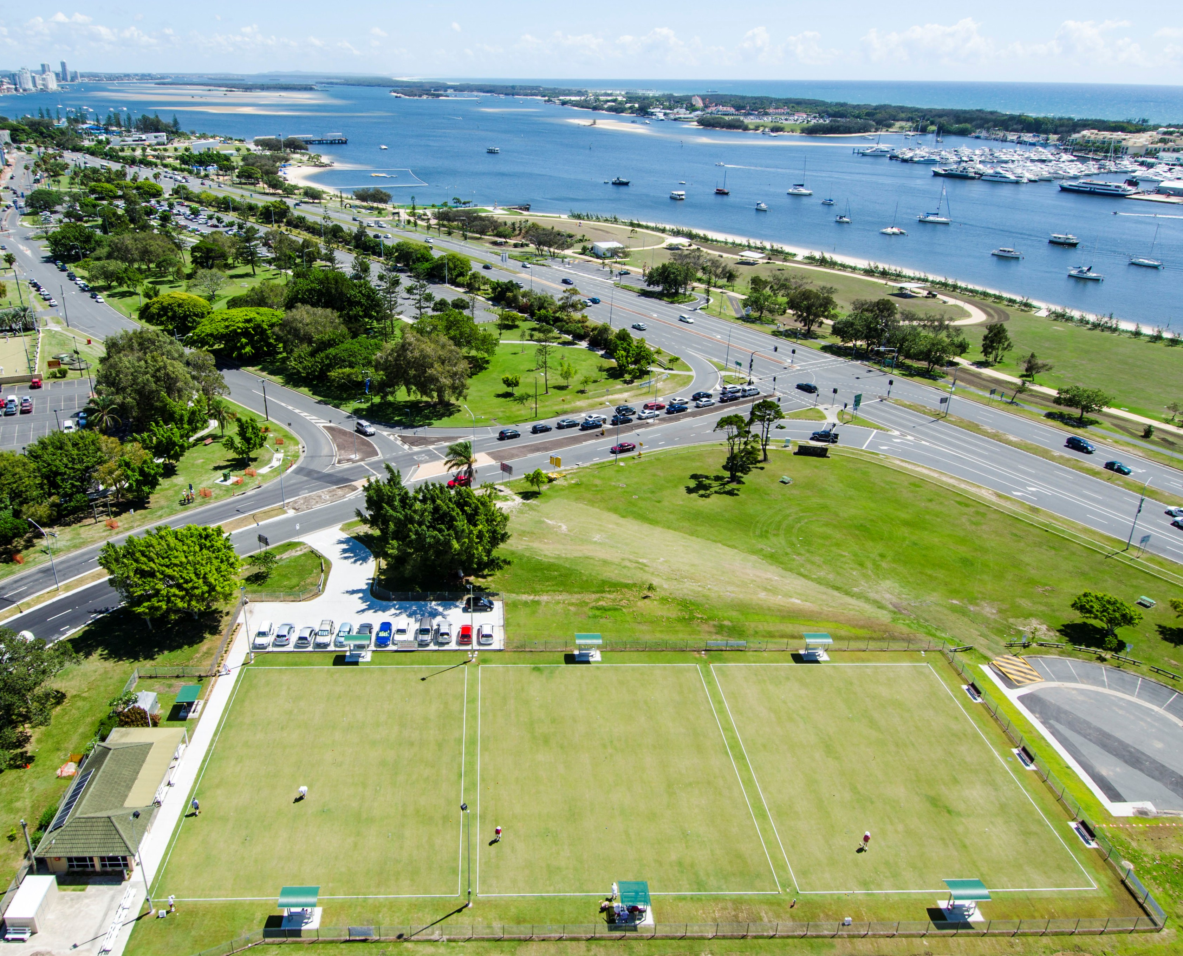

(Established 1935)
1 Queen Street Southport Qld 4215
PO Box 2034 Southport Qld 4215
Ph: (07) 5531 4720 (Mon - Wed – Sat)
Email: southport@croquetqld.org

Invites you to

Come to our Winter Carnival “Mallet Sports on the Broadwater”

June 21st 2013 June 24th 2013
Practice on Friday, 21st June.
Gateball Teams June 22nd – 23rd
Gateball Doubles June 23rd – 24th

Southport Croquet Club
Gold Coast Winter Carnival - 2013
Mallet Sports on The Broadwater.

We look forward to welcoming all entrants to the event, and assure you we are hoping to put on an occasion that will be enjoyable for all concerned. The time of year is ideal with a number of people coming for holidays to experience the Gold Coast Winter Festival time.

Conditions of the Tournament:

- Events will run according to the “Official Gateball Rules, Guide for Referees 2011” as published by the World Gateball Union.
- Each team must have a Manager and five to eight players. The Manager may be one of the players. The players must be affiliated with their State Croquet Association or their National Gateball organization.
- The Teams and Doubles Competition shall be played in a Round Robin or Block Format depending on the number of entries.
- All games shall be conducted with a Referee and a Recorder. All teams and double players shall be required to assist with refereeing, recording, scoring or linesman.
- Players shall provide their own sticks and number identification bibs.
- Teams are required to play in club uniform. Doubles players shall wear matching shirts and pants.
- Starting time 7.30am for 8.00am start of play.
- The Tournament Manager has the final decision concerning all matters affecting the running of the Events.
- The Manager of each team must report to the Tournament Manager before the start of the teams event and/or the doubles event with the list of players in the team or in the doubles.
- Cost per team is $70 and for doubles $8 each person.
- Entry forms must be received by Friday, 7th June, 2012.
- Catering costs are $5 for all day tea and coffee. For lunch and all day tea and coffee the cost will be $12.
- Prize money and badges will be awarded to 1st, 2nd and 3rd place getters in both Teams events and in Doubles.The names of all winners will be recorded on perpetual shields held at Southport Croquet Club.

Tournament Manager and Club Secretary
Barbara Northcott: 07 5577 507
email: barbaranorthcott@enfour.com

Club President
Julia Vickers : 07 5532 3521 email: jtvickers@bigpond.com

Club Phone 07 5531 4720 Mon. Wed. Sat. only
Club email: southport@croquetqld.org
Club Address: PO Box 2034 Southport, Qld, Australia, 4215

GATEBALL ENTRY FORM

Teams – Saturday 22nd & Sunday 23rd June 2013
Doubles - Sunday 23rd & Monday 24th June 2013

Closing date - JUNE 7th, 2013

Team $70 - Doubles $8 per player
Please make cheques payable to: ‘Southport Croquet Club Inc’ and return Entry Form and remittance to:
Mallet Sports on the Broadwater,
Southport Croquet Club,
PO Box 2034,
Southport, Queensland
Australia, 4215.

Contact Name …………………………………………..
Postal Address…………………………………………………………………..
Email Address……………………………………………
Phone Number…………………………………………..

Team Name | Entry Fee
 | $
 | $
Doubles  ……………………………..and …………………………… | $
Doubles  ……………………………..and …………………………… | $
Doubles  ……………………………..and …………………………… | $
TOTAL | $

