I have been playing Gateball for a few years now and have never got around to sourcing my own timer. I have always used the ones supplied by my club, which is fine, until you go to a Gateball day and realise you don’t have a timer. What to do?
Look no further, the answer is here. If you have an Android smartphone then the answer is here … the Gateball app. There are a couple to choose from, and upon looking at the logistics and reviews, I decided to give the below app a shot. And the best part is it’s FREE.
I have been using this app for a few weeks now and it works really well. It has the normal features of your wrist timers with a few additions and modifications.
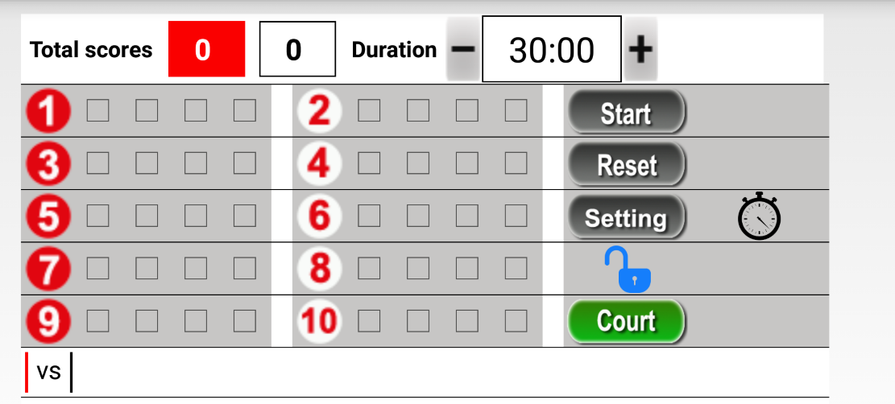
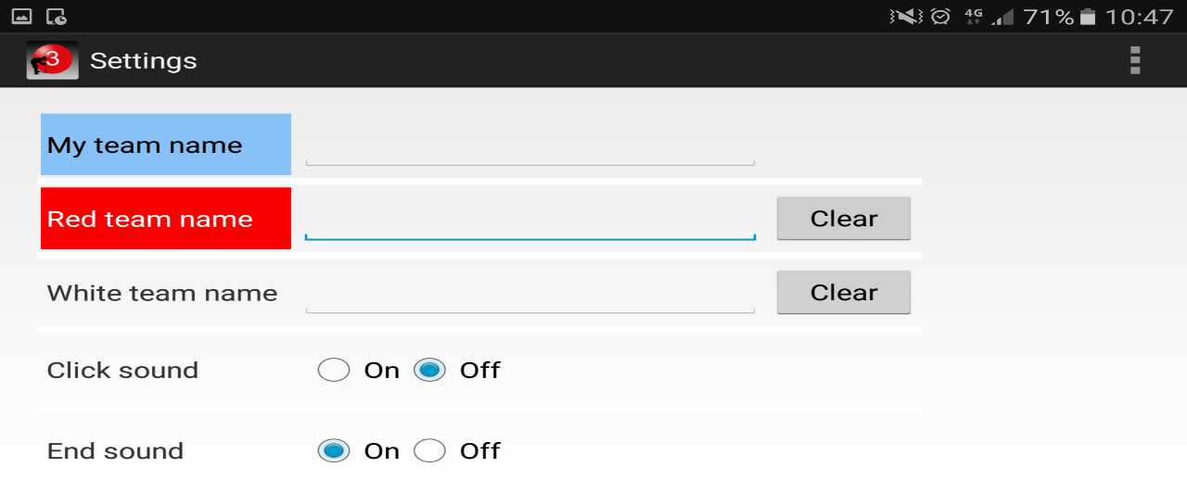
As you can see, it features the ball numbers, the 30min clock and the scores are displayed at the top of the screen. If you click on the settings button it takes you to the below screen;
In the settings screen you are able to name your teams as well as opting to use sound or not. If you decide to use the sound feature, it will give you the 15min warning as well as 10 and 5mins. It also begins to alarm during the final 10 seconds of play. If you enter any information into this screen, remember to save (this is below the end sound option … not pictured above)

Going back to the main screen, you will see there is a Green Court button. This takes you to a tactic board which you can use for strategizing or as a coaching method etc as you can place the balls anywhere on a picture of the court to explain moves, see below;
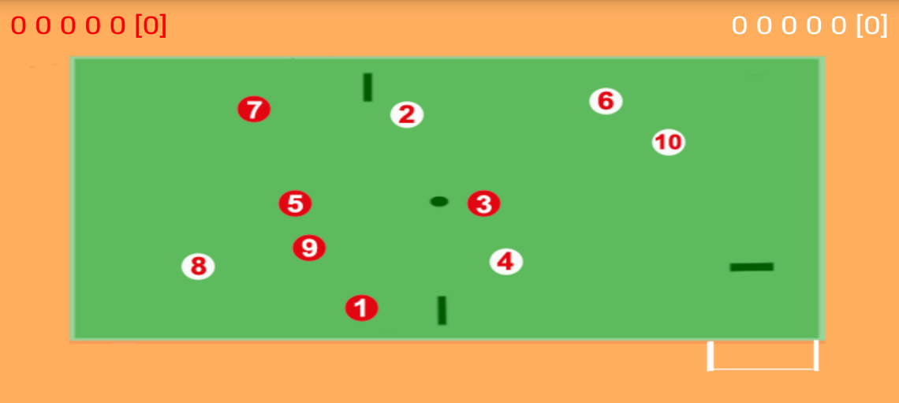
One of the key features I really like about this app is the screen lock feature. On the main scoreboard screen, you will see a picture of a padlock. If you click on the padlock, it will lock the screen and you won’t be able to adjust scores or reset the timer until you have unlocked it. I find this helpful as sometimes you might bump your wrist timer against yourself and accidentally add a gate that hasn’t happened and then confusion sets in and you lose focus. With the lock feature, this won’t happen . You just need to remember to lock and unlock the screen as you like.
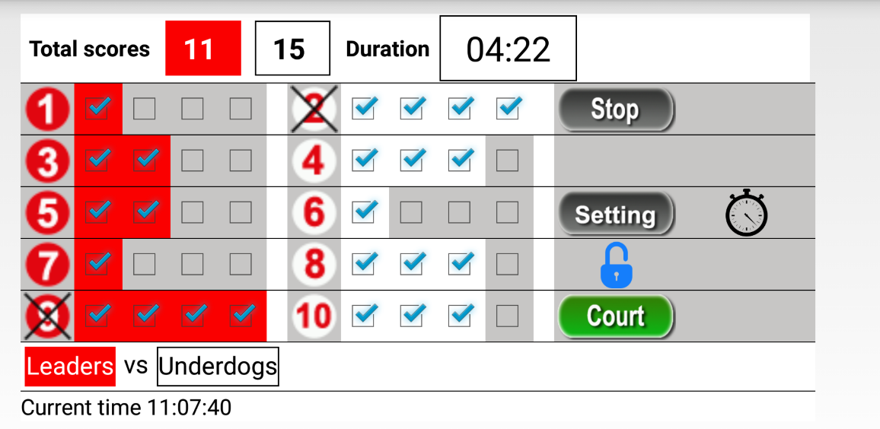

All in all, a simple and effective app to use if you don’t have your timer on you. All you need is an Android phone and an arm strap for easier use and you are good to go. So, come on gateballers, let’s give this technology a red hot go.
Tracey Shephard - Jamberoo

