2016 RIVERINA GATEBALL CHAMPIONSHIPS

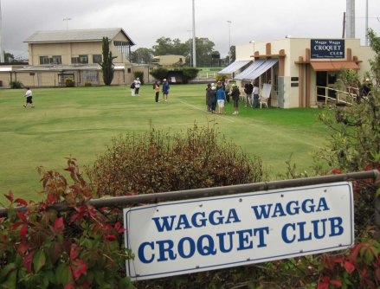

When: 3-4 September 2016

Where: Wagga Wagga Croquet Club (Fitzharding Street

Wagga Wagga)

2016 RIVERINA GATEBALL CHAMPIONSHIPS

Times: | Practice from 3:30pm Friday, 2nd September  Play commences 9:00am Saturday, 3rd September  Play commences 9:00am Sunday, 4th September
Venue: | Wagga Wagga Croquet Club, Fitzharding Street Wagga Wagga
Eligibility: | New South Wales Teams: players must be affiliated with the New South Wales Croquet Association. Teams may represent a croquet club or be formed by eligible players from a number of clubs.  Interstate Teams: players must be affiliated with their state croquet association.  Teams must have at least five players.  You are welcome to register as an individual. You will be placed in a team once all entries are known.
Equipment: | Courts will be prepared with gates, balls, and scoreboards. Players shall provide their own sticks and number bibs.
Rules: | The matches will be played under the Rules of Gateball as stated in the ‘Official Gateball Rules & Guide for Referees’ published by the World Gateball Union.
Referees: | All matches will be conducted with a referee if numbers allow. Teams will be required to assist with referee duties.
Match Format: | The teams event will be played in a block draw. The details will be decided when the number of entries is known.  Matches will be of 30 minutes duration in accordance with the Rules of Gateball.  Depending on numbers and time a triples competition may be played on the Sunday.
Honour Board: | The honour board will be inscribed with the name of the winning team.
Dress Code: | Teams are asked to wear a uniform (or shirts of a similar colour) where possible.
Inclement Weather: | The Tournament Manager reserves the right to make changes to the format of play due to inclement weather or other contingencies.
Entry Fee: | $10 per person (includes morning and afternoon tea)
Refreshments: | Lunch will be available for purchase on both days. ($10 per person per day)
Saturday Dinner: | A dinner will be held on the night of Saturday 23rd September. More information will be available when numbers and location are set.
Tournament Manager: | Joshua Willsher  Phone: 6933 4907  Email: joshua.willsher@bigpond.com
Entries Close:

2016 RIVERINA GATEBALL CHAMPIONSHIPS
ENTRY FORM

Team Name:
Team Manager:
Email:
Phone:

Player Name | Lunch Saturday | Lunch Sunday | Dinner | Dietary Requirements

